Beyond Steady-State Adaptation: Evaluating the Dynamic Performance of Biological Feedback Control
Athena Tamayo-Luisce^{1,2,3}, Mariana Gómez-Schiavon^{1,2*}
1 Laboratorio Internacional de Investigación sobre el Genoma Humano, Universidad Nacional Autónoma de México, Santiago de Querétaro, México.
2 ANID—Millennium Science Initiative Program—Millennium Institute for Integrative Biology (iBio), Santiago 8331150, Chile.
3 Licenciatura en Ciencias Genómicas, Centro de Ciencias Genómicas, Universidad Nacional Autónoma de México, Cuernavaca, México.
* MGSchiavon@liigh.unam.mx

Abstract
Organisms rely on feedback control mechanisms to maintain key biological variables within functional ranges despite persistent perturbations. Understanding how effectively these mechanisms maintain homeostasis is fundamental, yet quantitative evaluation of feedback performance remains challenging in nonlinear biological systems. Our previously developed framework, Control Ratio (CoRa), addresses this challenge by isolating the contribution of a feedback interaction through controlled comparison with an otherwise identical system in which that interaction has been removed. However, because CoRa evaluates adaptation solely through steady-state responses, it cannot distinguish controllers that ultimately recover to the same state but follow markedly different transient trajectories, despite the potentially profound physiological consequences of those dynamics. Here, we introduce CoRaDyn, a framework for evaluating adaptation as a dynamic process rather than solely as a steady-state outcome. Building on the comparative strategy introduced in CoRa, CoRaDyn quantifies the cumulative effect of feedback throughout the post-perturbation response, generating a time-dependent characterization of feedback performance. This approach reveals how the contribution of feedback depends not only on system parameters but also on the time horizon over which adaptation is evaluated, allowing distinct physiological objectives—such as rapid recovery or the generation of transient pulses—to be systematically compared. We demonstrate CoRaDyn using a gene regulatory circuit implementing proportional-integral-derivative (PID) control. Whereas CoRa predicts identical perfect adaptation for all controllers containing integral feedback, CoRaDyn discriminates their transient performance, quantifies the dynamic contributions of proportional and derivative control, and reveals trade-offs that are invisible to steady-state analyses. By extending feedback evaluation from endpoints to the full adaptation process, CoRaDyn broadens the scope of biological questions that can be addressed using the CoRa framework and provides a general approach for comparing feedback architectures when transient dynamics are central to biological function.

Author summary
Living cells continuously experience changes in their internal and external environments. Feedback control helps them cope with these disturbances by regulating biological processes to maintain proper function. Two concepts are commonly used to describe these behaviors: homeostasis, which emphasizes the ability of a system to recover after a disturbance, and biochemical adaptation, which focuses on the transient response that allows cells to detect and respond to environmental changes. Although these phenomena are often studied separately, they are complementary manifestations of the same underlying feedback process. Most existing methods for evaluating biological feedback focus on the final outcome of adaptation, asking whether a system eventually returns to its original state. However, the path taken to reach that state can be equally important, as different transient responses may have profoundly different physiological consequences. In this work, we present CoRaDyn, a computational framework that quantifies the contribution of feedback throughout the entire response to a perturbation rather than only at steady state. Using a gene regulatory circuit with proportional-integral-derivative (PID) control, we show that CoRaDyn distinguishes feedback strategies that appear identical under steady-state analysis while revealing differences in their dynamic performance. By evaluating adaptation as a process instead of only as an endpoint, CoRaDyn provides a general framework for studying how feedback shapes biological behavior across diverse physiological contexts.

0.0.0.1 Keywords:
Homeostasis; Biochemical adaptation; Feedback control; Transient dynamics.

Introduction
Living systems continuously experience changes in both their internal and external environments. To maintain proper function despite these persistent perturbations, they rely on feedback control mechanisms that regulate key biological variables over time ([REFs]). The dynamic behavior of these feedback systems underlies diverse physiological phenomena, making it crucial to understand how feedback control shapes biological behavior.
A major challenge in evaluating biological feedback control is disentangling the contribution of the feedback mechanism itself from the many interacting processes that shape the behavior of nonlinear biological systems. To address this problem, we previously developed the Control Ratio (CoRa) framework, which isolates the contribution of feedback by comparing a feedback-controlled system with an otherwise identical system lacking feedback ([REFs]). By quantifying the steady-state response to a perturbation, CoRa provides a rigorous and general framework for evaluating how effectively feedback restores the system after disturbance, independently of the particular nonlinear properties of the underlying biological network. However, by design CoRa evaluates adaptation through its steady-state outcome, it cannot distinguish systems that achieve the same level of adaptation through fundamentally different transient responses.
The importance of considering transient dynamics becomes evident when examining two of the best-known manifestations of biological feedback: homeostasis and biochemical adaptation. Homeostasis emphasizes the ability of a system to maintain key biological variables within physiologically relevant ranges despite persistent perturbations (e.g., [REFs]), whereas biochemical adaptation emphasizes the transient response that allows a system to remain responsive to environmental changes while ultimately returning to its pre-perturbation state (e.g., [REFs]). Although these concepts are often discussed independently, both emerge from the same fundamental mechanism: regulating biological variables in changing environments through feedback control. Together, they highlight complementary aspects of the same adaptation process: homeostasis emphasizes the eventual recovery of the system, whereas biochemical adaptation depends critically on its transient response.
This distinction becomes particularly important because, in many biological systems, the transient response is as important as the eventual steady state. The speed of adaptation, the magnitude of transient excursions, or the generation of a temporary pulse may determine whether a physiological response is beneficial or detrimental [Ref]. Consequently, feedback systems that appear equivalent when evaluated solely by their steady-state adaptation may exhibit profoundly different biological behaviors. Thus, evaluating biological feedback requires characterizing not only the outcome of adaptation, central to homeostasis, but also the adaptation process itself, which shapes biochemical adaptation.
To address this challenge, we introduce CoRaDyn, a framework that builds on the controlled comparison established by CoRa while extending the evaluation of feedback performance from the endpoint of adaptation to the adaptation process itself. Rather than evaluating feedback performance solely through steady-state responses, CoRaDyn quantifies the cumulative contribution of feedback throughout the response to perturbation, generating a time-dependent characterization of feedback performance. This dynamic perspective enables the systematic comparison of feedback systems according to the distinct physiological objectives they must satisfy, including rapid recovery, limited transient deviations, or the generation of transient pulses. We demonstrate the approach using a gene regulatory circuit implementing proportional-integral-derivative (PID) control ([REFs]), showing that CoRaDyn distinguishes controllers that exhibit identical steady-state adaptation yet markedly different transient responses, and systematically quantifies the individual contributions of proportional and derivative control to the system’s dynamic performance. By moving beyond steady-state adaptation, CoRaDyn provides a general framework for studying how feedback control shapes biological behavior throughout the adaptation process.

CoRaDyn Formalism
CoRaDyn builds on the controlled comparison framework established by CoRa ([REF: Gómez-Schiavon & El-Samad, 2022) to quantify the dynamic contribution of feedback regulation in biological systems. Like CoRa, it relies on mathematical control comparisons ([REF: Alves & Savageau), evaluating the system of interest against a locally analogous system that is identical in every respect except for the removal of a specific feedback interaction. By isolating the effect of the feedback while preserving the remaining system architecture and operating point, this comparison attributes differences in the response to perturbation exclusively to the feedback mechanism under study.

0.0.0.2 Locally Analogous System.
To isolate the contribution of a specific feedback interaction to the response dynamics of a biological system, we construct a locally analogous system in which that interaction is removed, hereafter referred to as the feedback-disrupted () system. The original and feedback-disrupted systems contain the same biochemical reactions and are described by the same set of differential equations with parameters , differing only in the removal of that interaction.
To ensure that the two systems are locally analogous, all reactions and parameter values are preserved (internal equivalence), while the removed feedback interaction is replaced by a constant input chosen so that all shared species attain the same pre-perturbation steady state (external equivalence). Under these conditions, both systems begin from the same operating point and differ exclusively in the presence or absence of that interaction. Consequently, any differences in their responses following a perturbation can be uniquely attributed to the functional contribution of the feedback.
The locally analogous system can be constructed for any individual feedback loop, even in systems containing multiple interacting feedback mechanisms, provided two conditions are satisfied. First, the perturbation must not affect the constant input introduced in the feedback-disrupted system; otherwise, the observed differences cannot be uniquely attributed to the removed feedback interaction. Second, the perturbation must act downstream of the removed feedback interaction and upstream of the controlled species (), ensuring that the perturbation propagates through the portion of the system regulated by the interaction under study. A detailed procedure for constructing locally analogous systems and implementing CoRaDyn is provided in Supplementary Information.

0.0.0.3 From Steady-State to Dynamic Comparison.
Up to this point, CoRaDyn follows the same controlled comparison framework as CoRa. The key distinction lies in how the effect of the feedback interaction is quantified. CoRa evaluates feedback performance from the change in the steady-state value of the controlled variable following a perturbation. In contrast, CoRaDyn quantifies the normalized cumulative effect over the entire response of , comparing the full response trajectories of the original and feedback-disrupted systems rather than only their final values. This trajectory-level comparison captures differences in the adaptation process, including transient dynamics and temporal delays introduced by the feedback, providing a more comprehensive characterization of feedback performance.
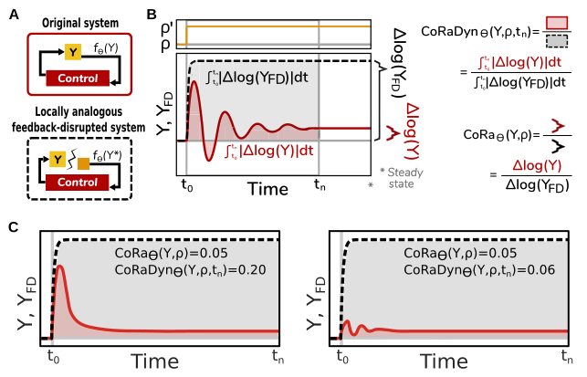
Explaining the CoRaDyn approach. (A) Schematic of an original feedback-regulated system (top) and its locally analogous feedback-disrupted counterpart (bottom), constructed by removing the feedback interaction under investigation while maintaining the same pre-perturbation steady state. The removed interaction is replaced by a constant input chosen so that the feedback signal is matched before perturbation. (B) Time-course responses of in the original (red solid line) and feedback-disrupted (black dashed line) systems following a perturbation . The original CoRa metric quantifies feedback performance from the relative change in steady-state output, ${\rm CoRa}_{\Theta}(Y,\rho) = {\Delta {\rm log}(Y)}/{\Delta {\rm log}(Y_{FD})}$. In contrast, CoRaDyn compares the full response trajectories by integrating the absolute logarithmic deviations over time up to an evaluation time , ${\rm CoRaDyn}_{\Theta}(Y,\rho,t_n) = {\int_{t_0}^{t_n} \left| \Delta \log Y(t) \right| dt}/{\int_{t_0}^{t_n} \left| \Delta \log Y_{FD}(t) \right| dt}$. This captures the cumulative contribution of feedback throughout the response to perturbation, rather than only its endpoint. (C) Illustration of two systems with identical CoRa values, indicating equivalent feedback performance when assessed solely from steady-state adaptation, but different CoRaDyn values, revealing distinct dynamic contributions of feedback during the adaptation process.
Owing to the normalization inherent to the CoRaDyn formulation (see Supplementary Information), its values lie between 0 and 1 and are directly comparable to those of CoRa. In both metrics, lower values indicate that the feedback attenuates the effect of the perturbation, thereby providing greater control. Specifically, ${\rm CoRaDyn}_{\Theta}(Y,\rho,t_n)\in(0,1)$ reflects a graded dynamic contribution of the feedback, whereas ${\rm CoRaDyn}_{\Theta}(Y,\rho,t_n)=1$ indicates that the original and feedback-disrupted systems respond identically, implying that the disrupted interaction provides no effective control. Unlike CoRa, however, CoRaDyn cannot attain a value of zero. Because feedback acts only after the perturbation has affected the system, the controlled variable must necessarily undergo a transient deviation from its pre-perturbation steady state. Consequently, the integrated deviation in the numerator of Eq. [Eq:CoRaDyn] is always strictly positive. It may, however, become arbitrarily small as the effectiveness of the feedback approaches perfect adaptation and the evaluation time is extended.
A key distinction between CoRa and CoRaDyn is that lower values do not necessarily imply better system performance. Rather, the interpretation of CoRaDyn depends on the regulatory objective of the system under study. Systems optimized to minimize deviations from their operating point generally exhibit lower CoRaDyn values, whereas systems that require a transient response before returning to equilibrium may exhibit larger values at early evaluation times that decrease as adaptation proceeds. Thus, unlike CoRa, which evaluates only the endpoint of adaptation, CoRaDyn captures differences in the dynamic response to perturbation and can distinguish regulatory strategies with similar steady-state outcomes.

0.0.0.4 Time-Dependent Characterization of Feedback Performance.
The evaluation time defines the temporal window over which the dynamic contribution of feedback is quantified. Although CoRaDyn can be evaluated at a single time point, its full temporal behavior is revealed by computing the metric across a range of evaluation times. This generates a time-dependent profile of feedback performance, ${\rm CoRaDyn}_{\Theta}(Y,\rho,t)$, which captures how the contribution of feedback evolves throughout the response to perturbation (Fig. 2A).
At times immediately following the perturbation, the original and feedback-disrupted systems remain similar due to their locally analogous construction, resulting in values of CoRaDyn close to one. As the feedback interaction begins to influence the system dynamics, differences between the two trajectories emerge, and CoRaDyn decreases according to the extent and timescale of the corrective response. Thus, the temporal profile of CoRaDyn provides information about when and how strongly feedback contributes to adaptation, rather than only whether the system eventually reaches a controlled state.
At long evaluation times, CoRaDyn approaches the steady-state contribution of feedback captured by CoRa. For systems that reach a new steady state following the perturbation, increasing progressively reduces the relative contribution of transient differences and causes CoRaDyn to converge toward the corresponding CoRa value. In contrast, for systems exhibiting persistent oscillations or other non-steady-state behaviours, this convergence is not expected, and the temporal profile itself becomes the relevant characterization of feedback performance.
Beyond time-dependent analyses, CoRaDyn can also be systematically evaluated across parameter ranges to visualize how feedback performance changes with the underlying system properties. For a parameter , computing ${\rm CoRaDyn}_{\Theta}(Y,\rho,t_n)$ across different values of generates a dynamic characterization of feedback performance across parameter space (Fig. 2B-C). For each parameter value, the feedback-disrupted system must be reconstructed to preserve the conditions of a mathematically controlled comparison. Together, parameter- and time-dependent analyses provide a multidimensional view of feedback function, revealing how regulatory architectures shape both the magnitude and timescale of control.
Finally, unlike CoRa, which is defined in terms of local steady-state changes and is therefore insensitive to perturbation magnitude in the limit of sufficiently small perturbations, CoRaDyn may exhibit some dependence on . For most systems and sufficiently small perturbations, this dependence is minimal. However, because CoRaDyn captures transient dynamics, its value may vary when perturbations alter the qualitative response trajectory, particularly near bifurcation points. For example, perturbations of different magnitudes may induce qualitatively distinct behaviours, such as damped versus sustained oscillations, resulting in different temporal profiles and CoRaDyn values (Fig. 6). Therefore, while maintaining the perturbative regime required for controlled comparison, perturbation magnitude should be considered when interpreting dynamic feedback performance, particularly in systems operating near dynamical transitions.
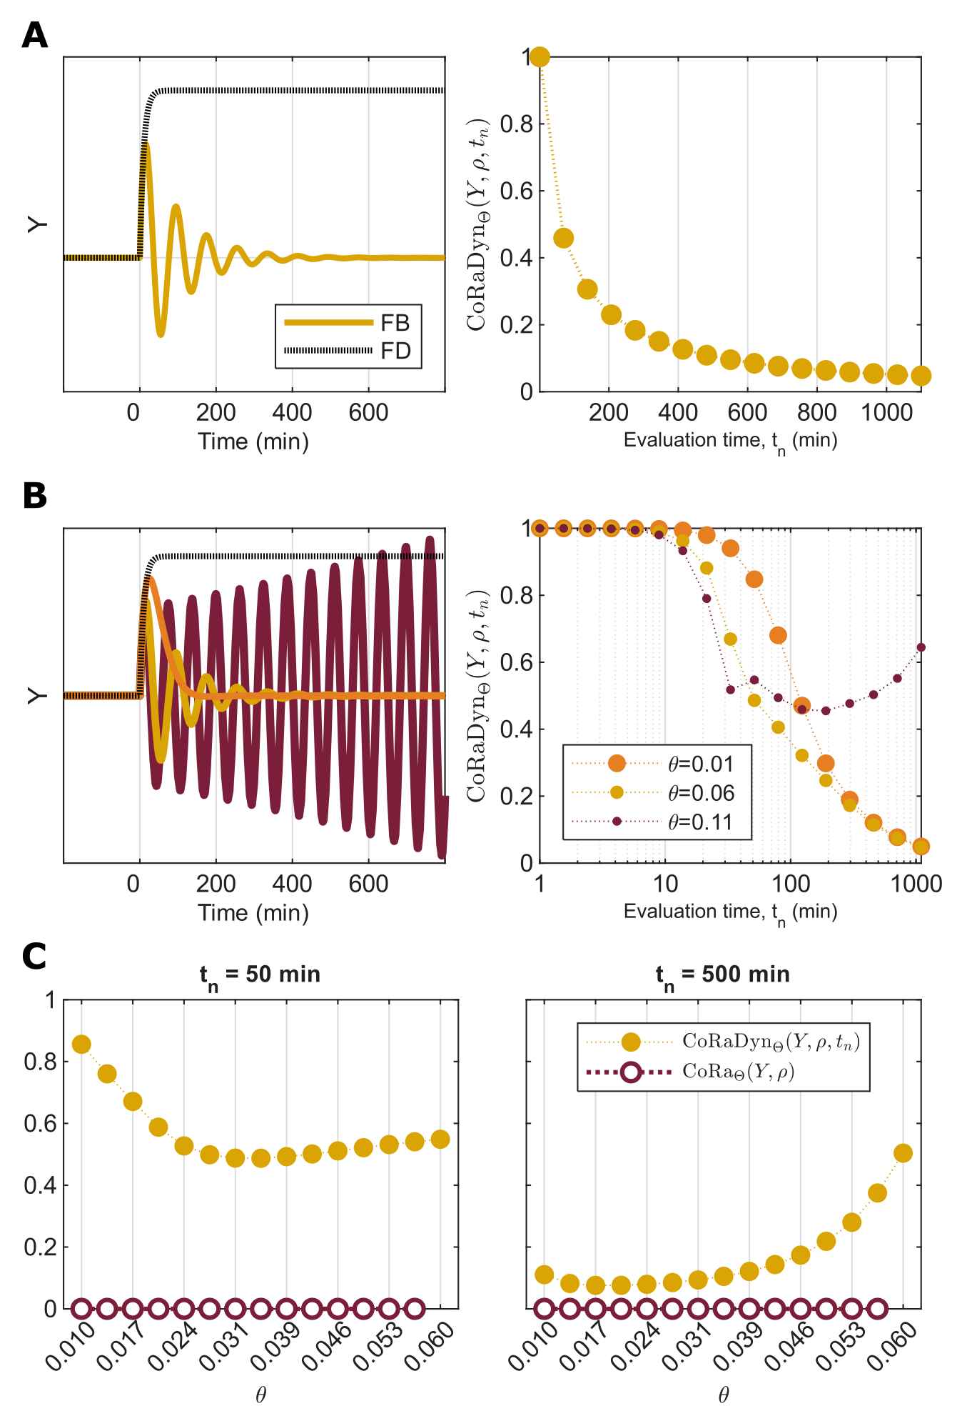
Time-dependent characterization of feedback performance using CoRaDyn. A: Example of a CoRaDyn temporal profile, obtained by evaluating feedback performance over increasing evaluation times. On the left, the dynamic responses of the original (solid red) and feedback-disrupted (dashed black) systems are shown; on the right, the corresponding change in CoRaDyn as the evaluation time () increases is shown. This example corresponds to a system with perfect adaptation, for which the steady-state CoRa value is zero. B: Example of how the CoRaDyn temporal profile varies as a parameter changes. On the left, the dynamic responses of the original (solid lines) and feedback-disrupted (dashed lines) systems are shown for three values of ; on the right, the corresponding temporal profiles of CoRaDyn are shown. C: Examples of CoRaDyn values evaluated at short (; left) and long (; right) evaluation times, together with the corresponding CoRa values, as a parameter varies. For the largest value of shown, the system exhibits sustained oscillations; therefore, CoRa cannot be defined, whereas CoRaDyn remains applicable. See Supplementary Information for equations and Table 2 for parameter values.

Stress-testing CoRaDyn with biomolecular PID control
As a stress-test for the application and power of CoRaDyn, we consider the proportional-integral-derivative (PID) controller implemented with biomolecular components, originally proposed by Chevalier et al. (2019; Fig. 3A). PID control provides an ideal benchmark because it combines feedback mechanisms with distinct and potentially competing dynamical objectives: integral feedback ensures perfect adaptation, whereas proportional and derivative feedback regulate the speed and stability of the response. Thus, although all PID configurations can potentially achieve the same adapted steady state, their transient behaviors can differ substantially—differences that are invisible to endpoint measures such as CoRa, but can be captured by CoRaDyn.
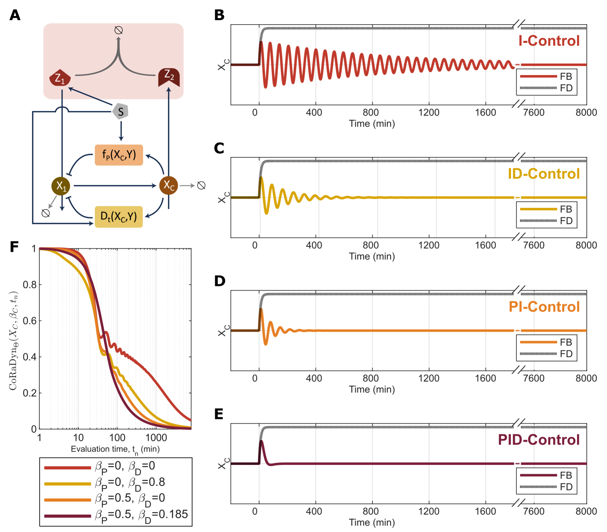
Feedback contribution depends on the temporal scale of evaluation. A: Schematic representation of the biomolecular PID controller analyzed in this study (adapted from Chevalier et al., 2019). The integral (I), proportional (P), and derivative (D) feedback modules are highlighted in red, orange, and yellow, respectively. B–E: Dynamic responses to a step perturbation for four controller configurations: (B) integral-only (I; , ), (C) integral-derivative (ID; ), (D) integral-proportional (PI; ), and (E) full PID control. All configurations exhibit perfect adaptation and therefore have identical steady-state CoRa values (${\rm CoRa}=0$), despite their distinct transient responses. F: CoRaDyn as a function of the evaluation time () for the four controller configurations shown in panels B–E. In all cases, CoRaDyn converges to zero as the systems approach their adapted steady states, but the trajectories differ substantially during the transient response. Differences in the initial decay of CoRaDyn and changes in the relative ranking of controller performance over time are observed. See Supplementary Information for equations and Table 2 for parameter values.
The integral component of the controller is implemented through the antithetic feedback (ATF) motif introduced by Briat et al. (2016). In this architecture, two molecular species mutually annihilate through binding, generating an integral control action that drives the steady-state error to zero under appropriate conditions. Consequently, the ATF motif provides the integral control action required for perfect adaptation to step perturbations (i.e., zero CoRa). However, integral control alone does not determine the qualitative dynamics of the response. Depending on parameter values, the system may either converge to the adapted steady state through slow transients or fail to settle altogether, exhibiting sustained oscillations. Thus, achieving perfect adaptation and satisfying physiological performance objectives are distinct properties of the controller.
The proportional and derivative components address these limitations by shaping the transient response. Proportional feedback responds to the magnitude of the deviation from the target state, accelerating recovery, whereas derivative feedback responds to the rate of change of this deviation, reducing overshoot and improving stability (Bennett, 1993). Therefore, the relative contribution of each feedback component depends on the temporal scale at which performance is evaluated—a feature that motivates the dynamic assessment provided by CoRaDyn.
In the model considered here, each control strategy is governed by a tunable weight— (integral), (proportional), and (derivative)—that determines its contribution to the overall controller. Moreover, each feedback loop can be selectively disrupted, enabling the controlled comparison of locally analogous systems and the quantification of individual feedback contributions using the CoRaDyn framework (see Supplementary Information for implementation details). In the following sections, we use the PID controller model of Chevalier et al. to illustrate three key capabilities of CoRaDyn: evaluating feedback performance across time, mapping the dependence of adaptation performance on control parameters, and dissecting the contribution of individual feedback components within a composite regulatory architecture.

0.0.0.5 Feedback contribution depends on the temporal scale of evaluation
To illustrate the importance of evaluation time, we compared four configurations of the biomolecular PID controller: integral-only control (I; 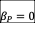, 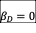), integral-derivative control (ID; ), integral-proportional control (PI; ), and the full PID controller. For each configuration, we simulated the response to an identical perturbation and computed CoRaDyn as a function of the evaluation time, (Fig. 3).
Because all four architectures contain the same integral control module, they achieve perfect adaptation following the perturbation and therefore have identical steady-state performance (${\rm CoRa}=0$). Consequently, CoRa cannot distinguish among these controllers despite their markedly different transient responses (Fig. 3B–E). CoRaDyn, in contrast, quantifies feedback performance throughout the adaptation process, revealing differences that are invisible to endpoint-based measures.
The resulting CoRaDyn trajectories (Fig. 3F) reveal distinct temporal profiles of feedback performance for the four controller architectures. In all cases, CoRaDyn decreases toward zero as the evaluation time increases, reflecting the progressive recovery of the perturbed system toward its adapted steady state. However, the rate of this decrease differs substantially across controllers, demonstrating that proportional and derivative feedback alter the transient contribution of feedback even though they do not affect the final adapted state. At early evaluation times, the ID controller exhibits the lowest CoRaDyn values, consistent with its ability to reduce the initial transient response. During the same period, the I and PI controllers display similar trajectories. As the response progresses, however, the PI controller surpasses the I controller, eventually catching up with the ID controller and reaching lower CoRaDyn values more rapidly. The full PID controller ultimately outperforms all other configurations, although this advantage only becomes apparent after the initial phase of the response.
Importantly, the relative performance of the different controllers is not constant over time. The CoRaDyn trajectories are non-monotonic with respect to one another, such that the controller exhibiting the strongest feedback contribution depends on the evaluation time selected. Thus, no single architecture can be considered uniformly superior without specifying the temporal objective of interest. This result highlights a key advantage of CoRaDyn: by explicitly incorporating the evaluation time, it enables feedback architectures to be compared according to the timescale over which adaptation is required, rather than solely according to their eventual steady-state behavior.

0.0.0.6 Evaluation time reveals distinct roles for proportional, integral, and derivative feedback.
The examples presented in Fig. 3 illustrate that the apparent contribution of proportional and derivative control depends strongly on the evaluation time. However, these conclusions correspond to a single parameterization of the PID controller and therefore should not be interpreted as general properties of the controller architecture. A key advantage of the CoRaDyn framework is that it enables systematic exploration of parameter space, allowing feedback performance to be compared across controller configurations and temporal objectives.
To verify that CoRaDyn remains consistent with established measures of transient performance, we first evaluated CoRaDyn at a fixed evaluation time (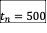 min) across the PID parameter space. The resulting performance landscapes closely resemble those previously obtained using adaptation time (Chevalier et al., 2019; Fig. 7), recovering the previously described approximately additive influence of proportional and derivative feedback, whereby increasing either control weight similarly improves transient performance. This agreement confirms that, when restricted to a single evaluation time, CoRaDyn captures the same qualitative trends identified using conventional transient metrics.
Unlike adaptation time, however, CoRaDyn is not limited to a single temporal summary of the response. Because it quantifies cumulative feedback performance over an arbitrary evaluation interval, the same collection of simulations can be interrogated across multiple temporal scales. Furthermore, whereas adaptation time becomes undefined when the perturbed system fails to converge within the observation window, CoRaDyn remains applicable to sustained post-perturbation oscillations. The parameter combinations for which CoRaDyn cannot be evaluated (white/empty regions in Fig. 7) instead correspond to systems lacking a stable pre-perturbation steady state. As with adaptation time and CoRa, a stable pre-perturbation steady state is required to define the reference condition (see Table 1).
To systematically investigate how the contribution of each control strategy changes over time, we summarized CoRaDyn across the explored controller parameter space using the median over the remaining controller weights. Specifically, we computed 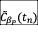, 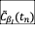, and 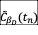, corresponding to the median CoRaDyn obtained for fixed proportional (), integral (), and derivative () control weights, respectively, while taking the median over all combinations of the remaining two controller weights (Fig. 4A; see caption for formal definitions). In all cases, the median CoRaDyn decreases with increasing evaluation time, reflecting the progressive recovery of the perturbed systems. However, the dependence of CoRaDyn on the individual controller weights varies substantially throughout the temporal profile. The complete distributions underlying these median summaries are shown as boxplots in Figs. 8 - 19.
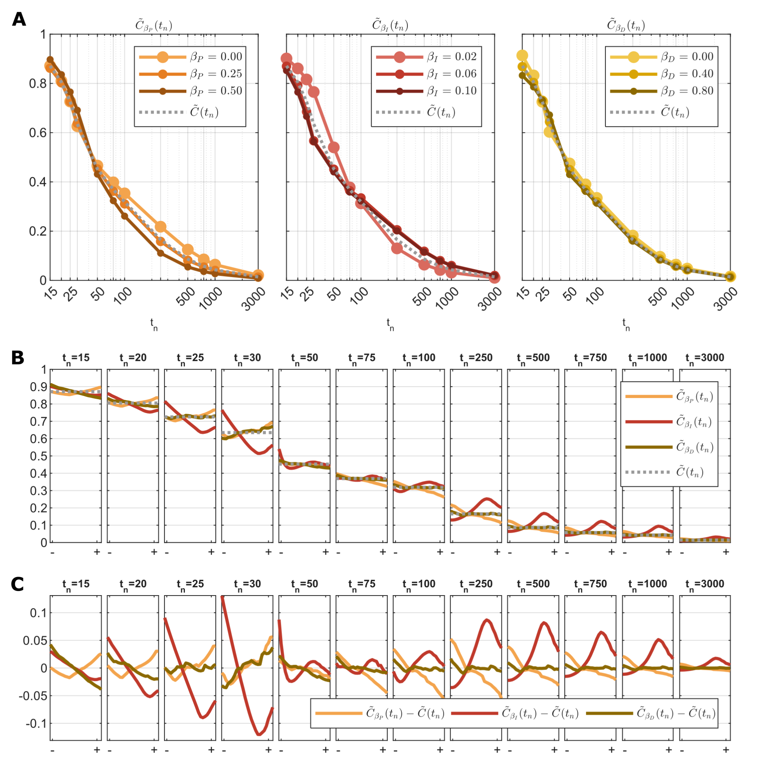
The contribution of proportional, integral, and derivative control depends on the evaluation time. A: Temporal profiles of the median CoRaDyn as a function of the evaluation time (; logarithmic scale). Each colored curve corresponds to the median CoRaDyn over all combinations of the remaining two controller weights for a fixed value of the indicated control weight, i.e., (left), (center), and (right). The dotted gray line denotes the global median across all controller weight combinations, . B: Median CoRaDyn as a function of each controller weight for representative evaluation times (indicated above each panel). Curves show , , and as the corresponding controller weight varies, from low () to high () values in the explored range, while the dotted gray line indicates the global median for that evaluation time. C: Same data as in B, shown as deviations from the global median. Curves represent , , and , highlighting the relative contribution of each control component with respect to the overall median CoRaDyn at each evaluation time. Supplementary Fig. 20 presents the same data reorganized by controller weight to facilitate comparison across evaluation times. See Supplementary Information for equations and Table 2 for parameter values.
At early evaluation times (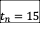 min), increasing the derivative control weight consistently decreases , indicating that derivative control contributes most strongly during the initial stages of the response. In contrast, the dependence on the proportional control weight is markedly non-monotonic, with intermediate values of yielding the lowest values of . Similar non-monotonic relationships emerge at many other evaluation times and for all three controller weights, demonstrating that the dynamic contribution of each feedback component cannot be characterized by a simple monotonic dependence on its strength.
The influence of the integral controller becomes particularly evident at longer evaluation times. For example, at 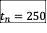 min, the smallest values of occur for the lowest values of , whereas larger—but not maximal—integral weights produce the largest values of . Moreover, often generates the widest spread in among the three controller weights, indicating that the contribution of integral feedback becomes increasingly sensitive to parameter selection as longer timescales are considered.
Together, these analyses demonstrate that the apparent importance of the proportional, integral, and derivative feedback components depends jointly on their control weights and on the temporal objective used to evaluate performance. Rather than providing a single measure of adaptation quality, CoRaDyn enables systematic exploration of how distinct controller architectures satisfy different dynamic objectives, revealing trade-offs that remain inaccessible to endpoint-based metrics.

0.0.0.7 Dissecting the Contribution of Individual Feedback Loops.
Finally, we demonstrate how CoRaDyn inherits one of the central principles of the original CoRa framework: the use of locally analogous systems to isolate the contribution of individual feedback loops while preserving the remainder of the network unchanged. Although this possibility was discussed in the original formulation of CoRa, it was not explicitly demonstrated. Here, we extend this principle to dynamic feedback evaluation, allowing the contribution of multiple feedback mechanisms to be quantified within a single controller architecture.
To illustrate this capability, we consider a fully configured PID controller and construct four locally analogous systems by selectively disrupting: (1) proportional feedback, (2) derivative feedback, (3) both proportional and derivative feedback, or (4) all feedback loops (Fig. 5). In contrast to the comparisons in Fig. 3, which contrasted distinct controller architectures, all controlled comparisons here are performed on the same underlying system and parameterization. Consequently, differences in CoRaDyn can be directly attributed to the specific feedback loop(s) disrupted.
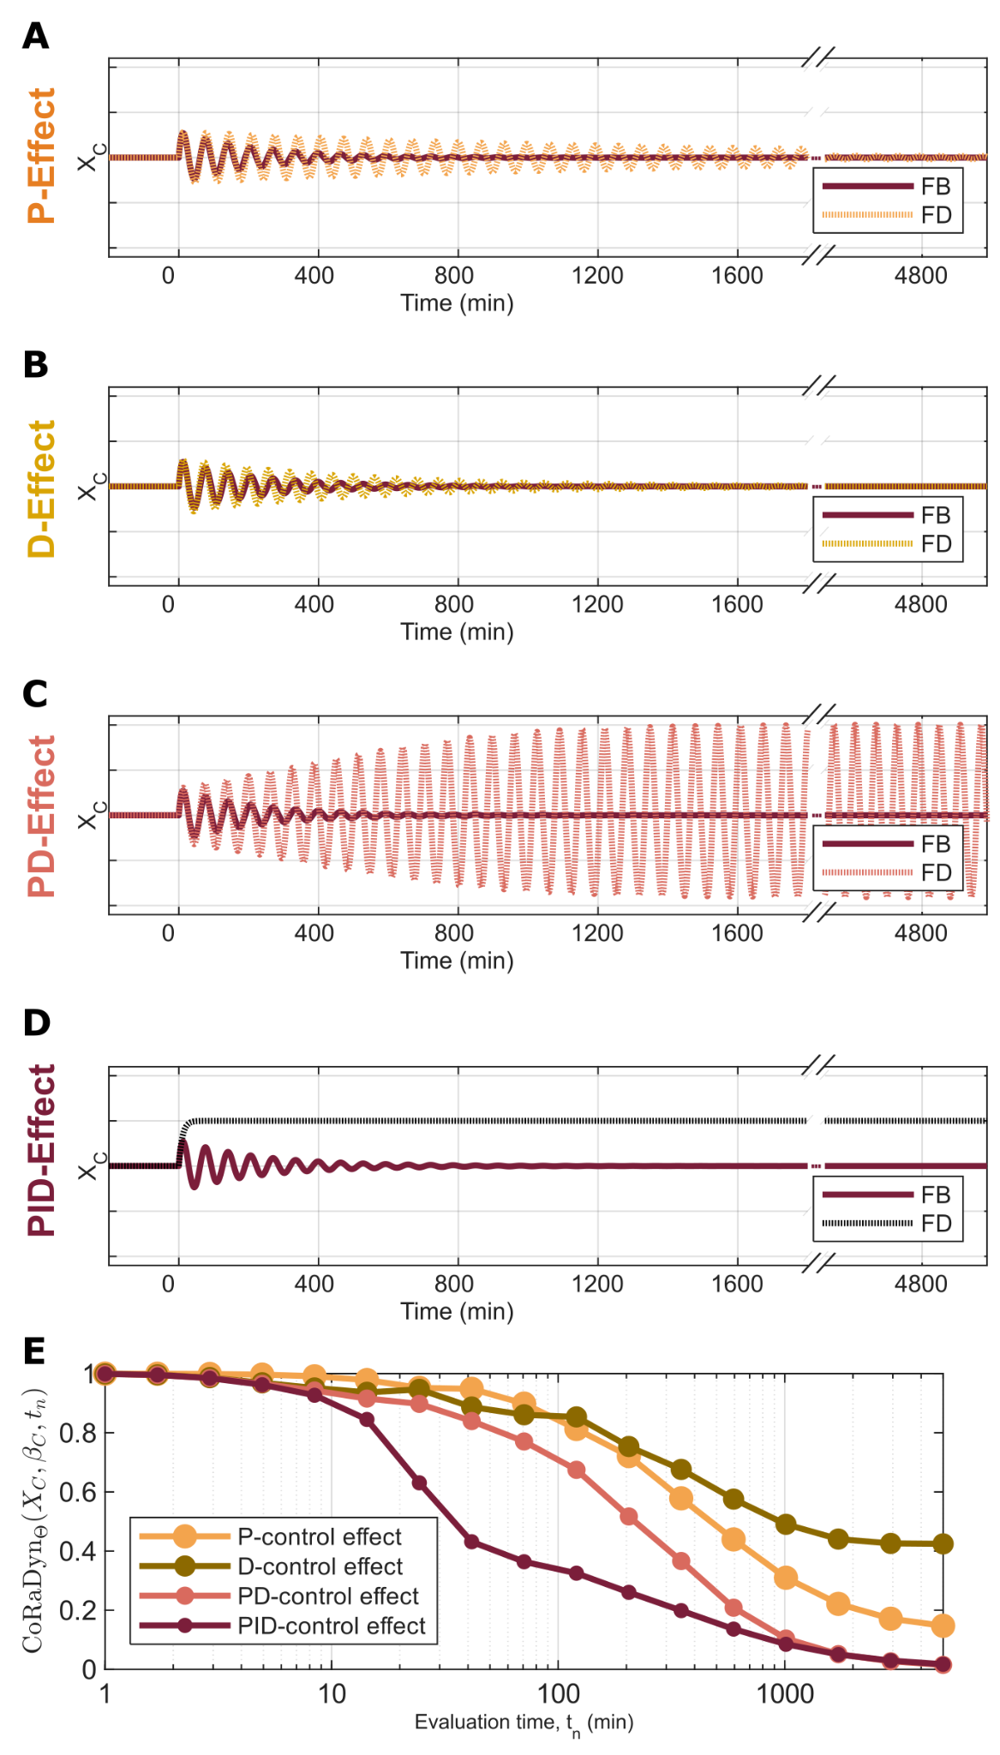
CoRaDyn isolates the dynamic contribution of overlapping feedback loops. A–D: Dynamic response of the controlled variable () following a step perturbation over applied at time zero. In each panel, the original PID controller (orange) is compared with its corresponding locally analogous system, in which selected feedback loops have been disrupted while preserving the remaining network unchanged: (A) proportional feedback removed (orange), (B) derivative feedback removed (yellow), (C) proportional and derivative feedback removed (red), and (D) all feedback loops removed (black). E: CoRaDyn as a function of the evaluation time () for the controlled comparisons shown in panels A–D, using the same color scheme. The inset highlights the early evaluation times. Because the locally analogous systems in panels A–C retain integral control, they exhibit perfect adaptation despite their altered transient responses. Consequently, CoRaDyn quantifies the cumulative dynamic contribution of the disrupted feedback loop(s), enabling the individual and combined effects of proportional, derivative, and integral control to be compared within the same controller architecture. See Supplementary Information for equations and Table 2 for parameter values.
For each controlled comparison, we computed CoRaDyn as a function of the evaluation time (Fig. 5E). Because the locally analogous systems in which only proportional and/or derivative feedback is disrupted retain integral control, they still exhibit perfect adaptation despite their altered transient responses. Consequently, the observed differences do not reflect changes in steady-state adaptation, but rather differences in the transient correction of the perturbation. Since CoRaDyn is evaluated relative to the corresponding locally analogous system, each trajectory quantifies the fraction of the perturbation remaining in the intact controller relative to the response expected in the absence of the disrupted feedback loop. Thus, lower CoRaDyn values indicate that the removed feedback mechanism contributed more strongly to correcting the perturbation. In contrast, the comparison in which all feedback loops are disrupted lacks integral control and therefore exhibits a sustained deviation from the adapted steady state.
The resulting CoRaDyn profiles reveal distinct contributions of the three control strategies. For the parameterization considered here, removing proportional feedback produces lower CoRaDyn values than removing derivative feedback over most evaluation times, indicating that proportional control contributes more strongly to the overall dynamic performance of the controller. When both proportional and derivative feedback are disrupted simultaneously, their combined effect is approximately additive, consistent with the behavior observed in the systematic parameter analysis (Fig. 7). However, inspection of the early evaluation times (inset, Fig. 5E) reveals a more nuanced picture: the CoRaDyn profiles associated with proportional and derivative feedback intersect repeatedly, demonstrating that their relative contributions change throughout the transient response. Thus, although proportional feedback dominates the cumulative response in this example, derivative feedback provides the greater benefit over specific temporal windows.
As in the previous analyses, these conclusions depend on the parameterization of the controller, and additional examples are provided in Fig. [SFig_FBs_Ex]. Nevertheless, the controlled comparison framework enables the contribution of each feedback mechanism to be interpreted directly from the CoRaDyn trajectories, providing a principled decomposition of dynamic feedback performance that is inaccessible to steady-state analyses alone. In particular, whereas CoRa assigns identical values to all controllers exhibiting perfect adaptation, CoRaDyn reveals how individual feedback loops contribute to different phases of the adaptive response, thereby extending the controlled comparison principle of CoRa from steady-state adaptation to transient dynamics.

Discussion
- How should the output be interpreted? Smaller values are not necessarily desired.
- What CoRaDyn tells us about the dynamic of a system? It cannot provide the adaptation time because the integral introduces a delay; however, calculating CoRa along the dynamics does.
- What value should be assigned to the upper integration limit?
- A brief summary of main take home points.

Conclusion
[Add conclusions.]

0.0.0.8 Data, Materials, and Software Availability.
Code and simulations have been deposited in GitHub (https://github.com/SysEvo/CoRa_Dynamics), and Zenodo (doi: ??). Equations, parameters values, and algorithms also appear in Supplementary Information.

Acknowledgments
This work was supported by the Programa de Apoyo a Proyectos de Investigación e Innovación Tecnológica (PAPIIT-UNAM; IA203524 to M.G.-S) and by the ANID—Millennium Science Initiative Program—Millennium Institute for Integrative Biology (iBio; ICN17_022 to M.G.-S). Athena Tamayo-Luisce acknowledges financial support through a fellowship from PAPIIT-UNAM (IA203524 to M.G.-S). Additionally, the authors thank Luis A. Aguilar from the Laboratorio Nacional de Visualización Científica Avanzada and Jair Santiago García Sotelo, Iliana Martínez, Rebeca Mucino, María Arteaga, and Eglee Lomelín from the Laboratorio Internacional de Investigación sobre el Genoma Humano, Universidad Nacional Autónoma de México, Santiago de Querétaro, México, for their support.

Supporting information

0.0.0.9 Supplementary Figures:
Fig S1-S15

0.0.0.10 Supplementary Tables:
Table S1-S3

0.0.0.11 Supplementary Text:
Section S1-S2

0.0.0.12 Supplementary Code:
UPDATE: https://github.com/mgschiavon/CoRa/releases/tag/v1.0
SUPPLEMENTARY INFORMATION
Beyond Steady-State Adaptation: Evaluating the Dynamic Performance of Biological Feedback Control
Athena Tamayo-Luisce^{1,2,3}, Mariana Gómez-Schiavon^{1,2*}
1 Laboratorio Internacional de Investigación sobre el Genoma Humano, Universidad Nacional Autónoma de México, Santiago de Querétaro, México.
2 ANID—Millennium Science Initiative Program—Millennium Institute for Integrative Biology (iBio), Santiago 8331150, Chile.
3 Licenciatura en Ciencias Genómicas, Centro de Ciencias Genómicas, Universidad Nacional Autónoma de México, Cuernavaca, México.
* MGSchiavon@liigh.unam.mx
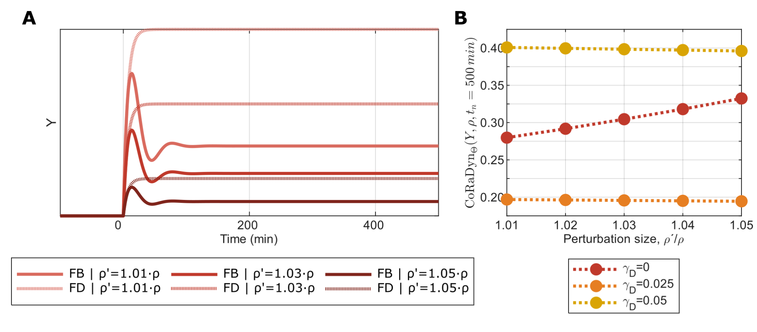
Effect of perturbation magnitude on CoRaDyn values. A: CoRaDyn as a function of the evaluation time () for an example system subjected to three different perturbation magnitudes, . B: CoRaDyn evaluated at min for a broader set of perturbation magnitudes spanning the same range illustrated in A and for three parameterizations of the system (, red, as shown in A; , orange; and , yellow). While CoRa is approximately independent of perturbation magnitude for sufficiently small perturbations, CoRaDyn may depend on perturbation magnitude, with the degree of sensitivity determined by the system dynamics and parameterization.
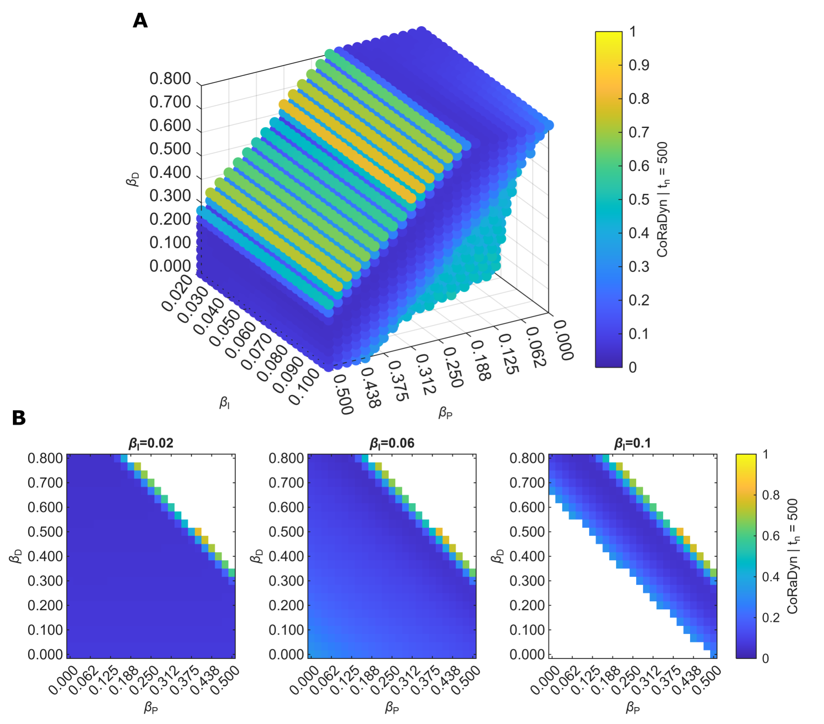
CoRaDyn evaluated at a fixed time reproduces the parameter dependence of PID control performance. CoRaDyn evaluated at a representative evaluation time ( min) over the proportional (), integral (), and derivative () controller weights. A: CoRaDyn across the complete explored parameter space. Axes correspond to the proportional (), integral (), and derivative () control weights. B: Two-dimensional slices of the parameter space for representative values of the integral control weight (, , and min; indicated above each panel). Colors indicate the CoRaDyn value according to the color scale. White regions indicate parameter combinations for which no stable pre-perturbation steady state exists and therefore CoRaDyn cannot be evaluated. See Supplementary Information for equations and Table 3 for parameter values.
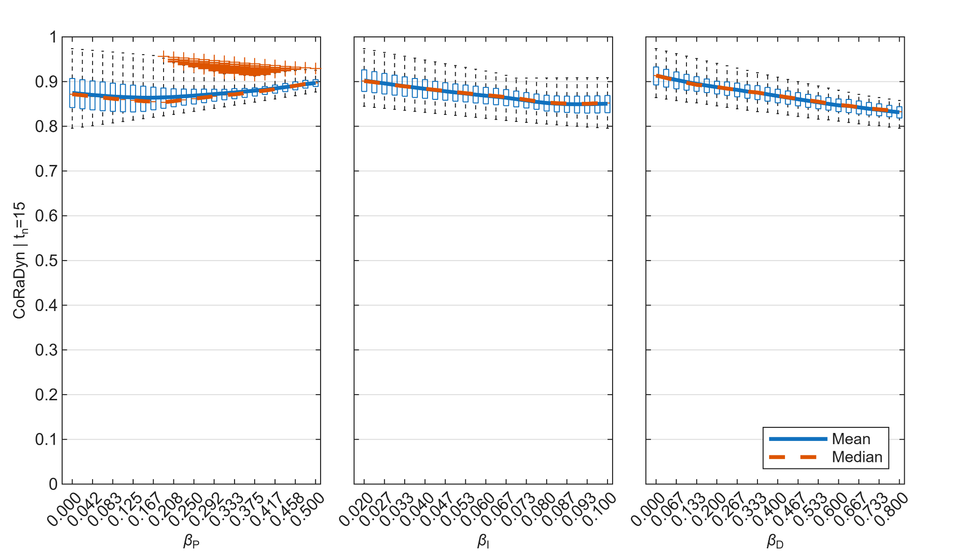
Distribution of CoRaDyn values across PID controller weights at min. Boxplots of CoRaDyn for fixed values of the proportional (; left), integral (; center), and derivative (; right) control weights. For each control weight value, the distribution is computed over all combinations of the remaining two controller weights. Blue lines denote the mean and red lines the median. See Supplementary Information for equations and Table 3 for parameter values.
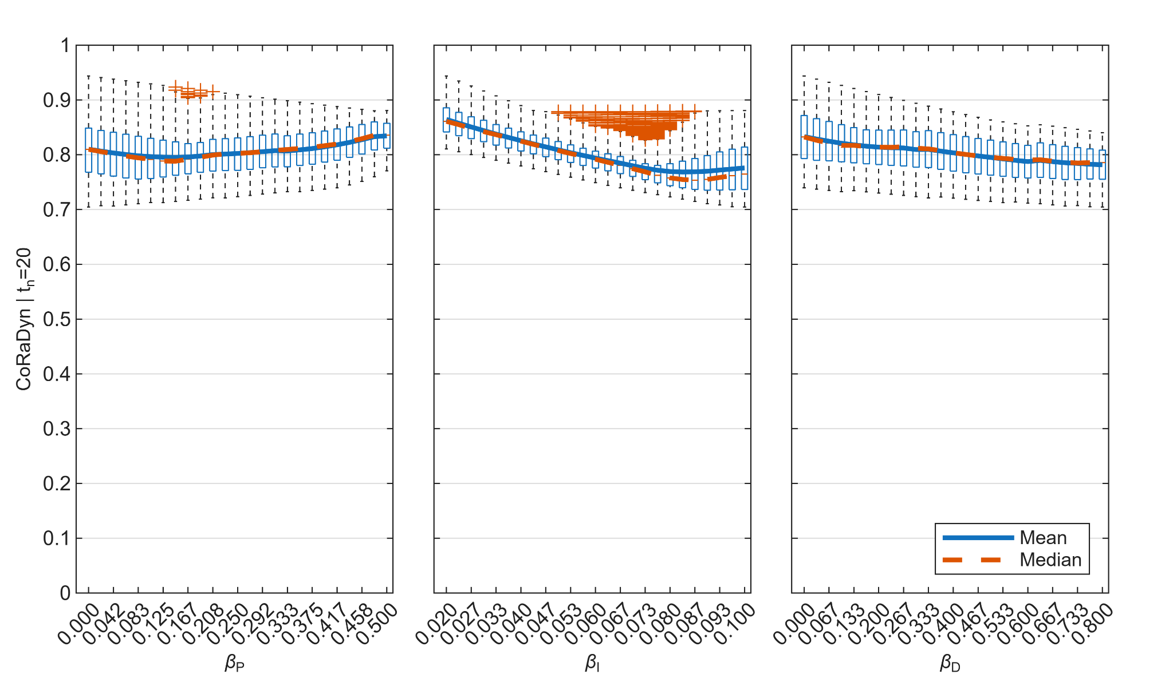
Distribution of CoRaDyn values across PID controller weights at min. Boxplots of CoRaDyn for fixed values of the proportional (; left), integral (; center), and derivative (; right) control weights. For each control weight value, the distribution is computed over all combinations of the remaining two controller weights. Blue lines denote the mean and red lines the median. See Supplementary Information for equations and Table 3 for parameter values.
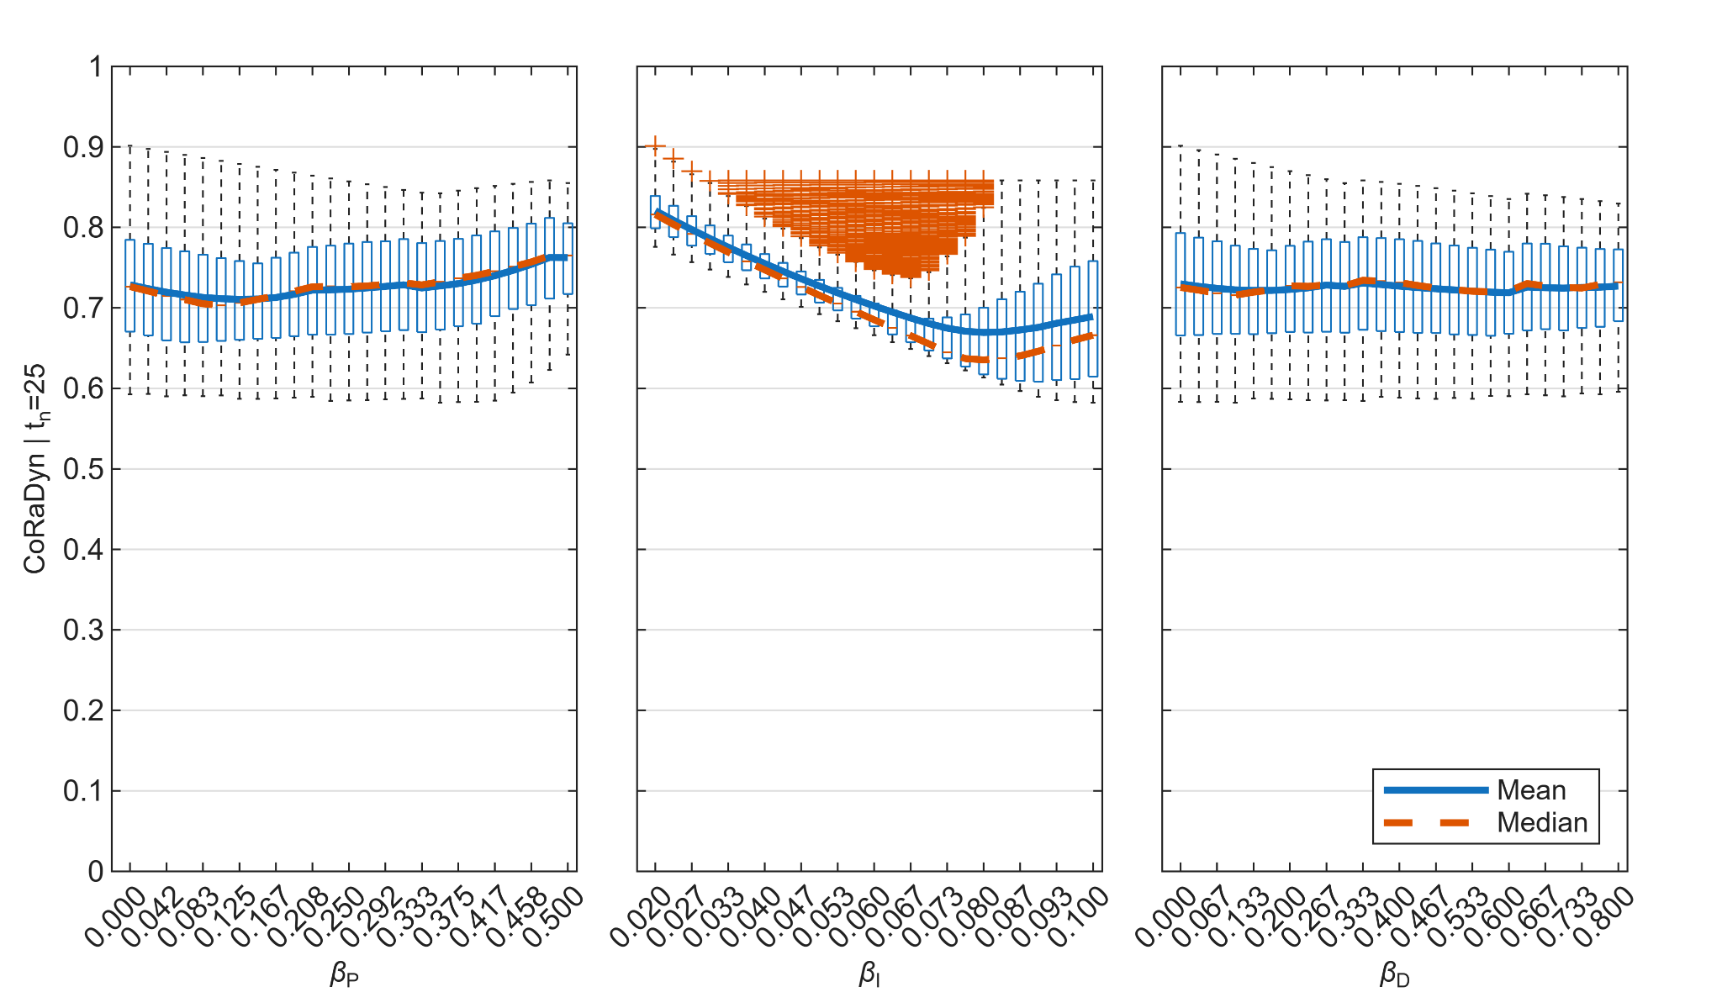
Distribution of CoRaDyn values across PID controller weights at min. Boxplots of CoRaDyn for fixed values of the proportional (; left), integral (; center), and derivative (; right) control weights. For each control weight value, the distribution is computed over all combinations of the remaining two controller weights. Blue lines denote the mean and red lines the median. See Supplementary Information for equations and Table 3 for parameter values.
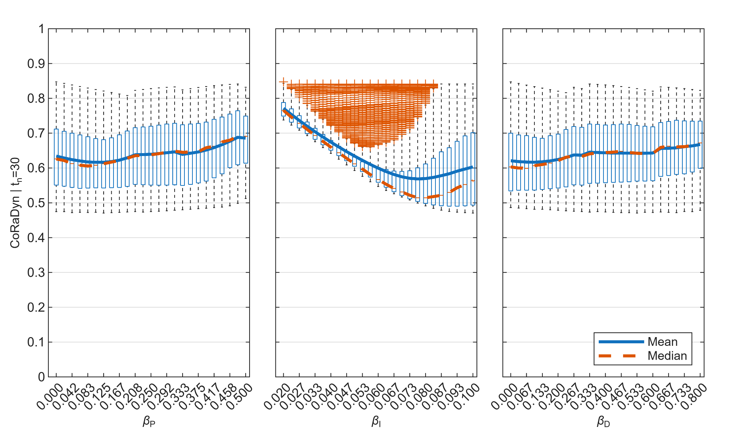
Distribution of CoRaDyn values across PID controller weights at min. Boxplots of CoRaDyn for fixed values of the proportional (; left), integral (; center), and derivative (; right) control weights. For each control weight value, the distribution is computed over all combinations of the remaining two controller weights. Blue lines denote the mean and red lines the median. See Supplementary Information for equations and Table 3 for parameter values.
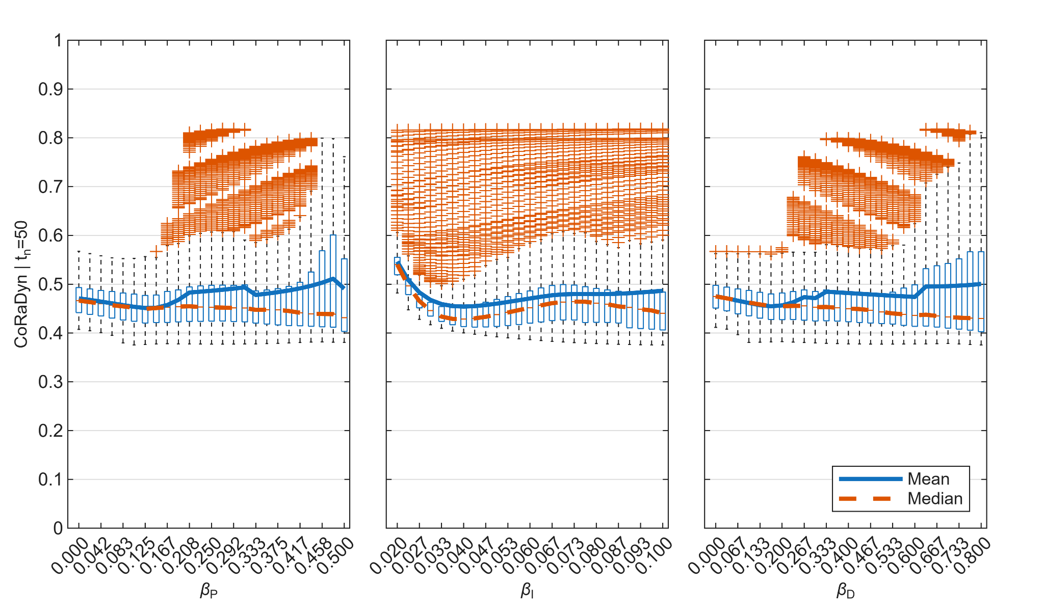
Distribution of CoRaDyn values across PID controller weights at min. Boxplots of CoRaDyn for fixed values of the proportional (; left), integral (; center), and derivative (; right) control weights. For each control weight value, the distribution is computed over all combinations of the remaining two controller weights. Blue lines denote the mean and red lines the median. See Supplementary Information for equations and Table 3 for parameter values.
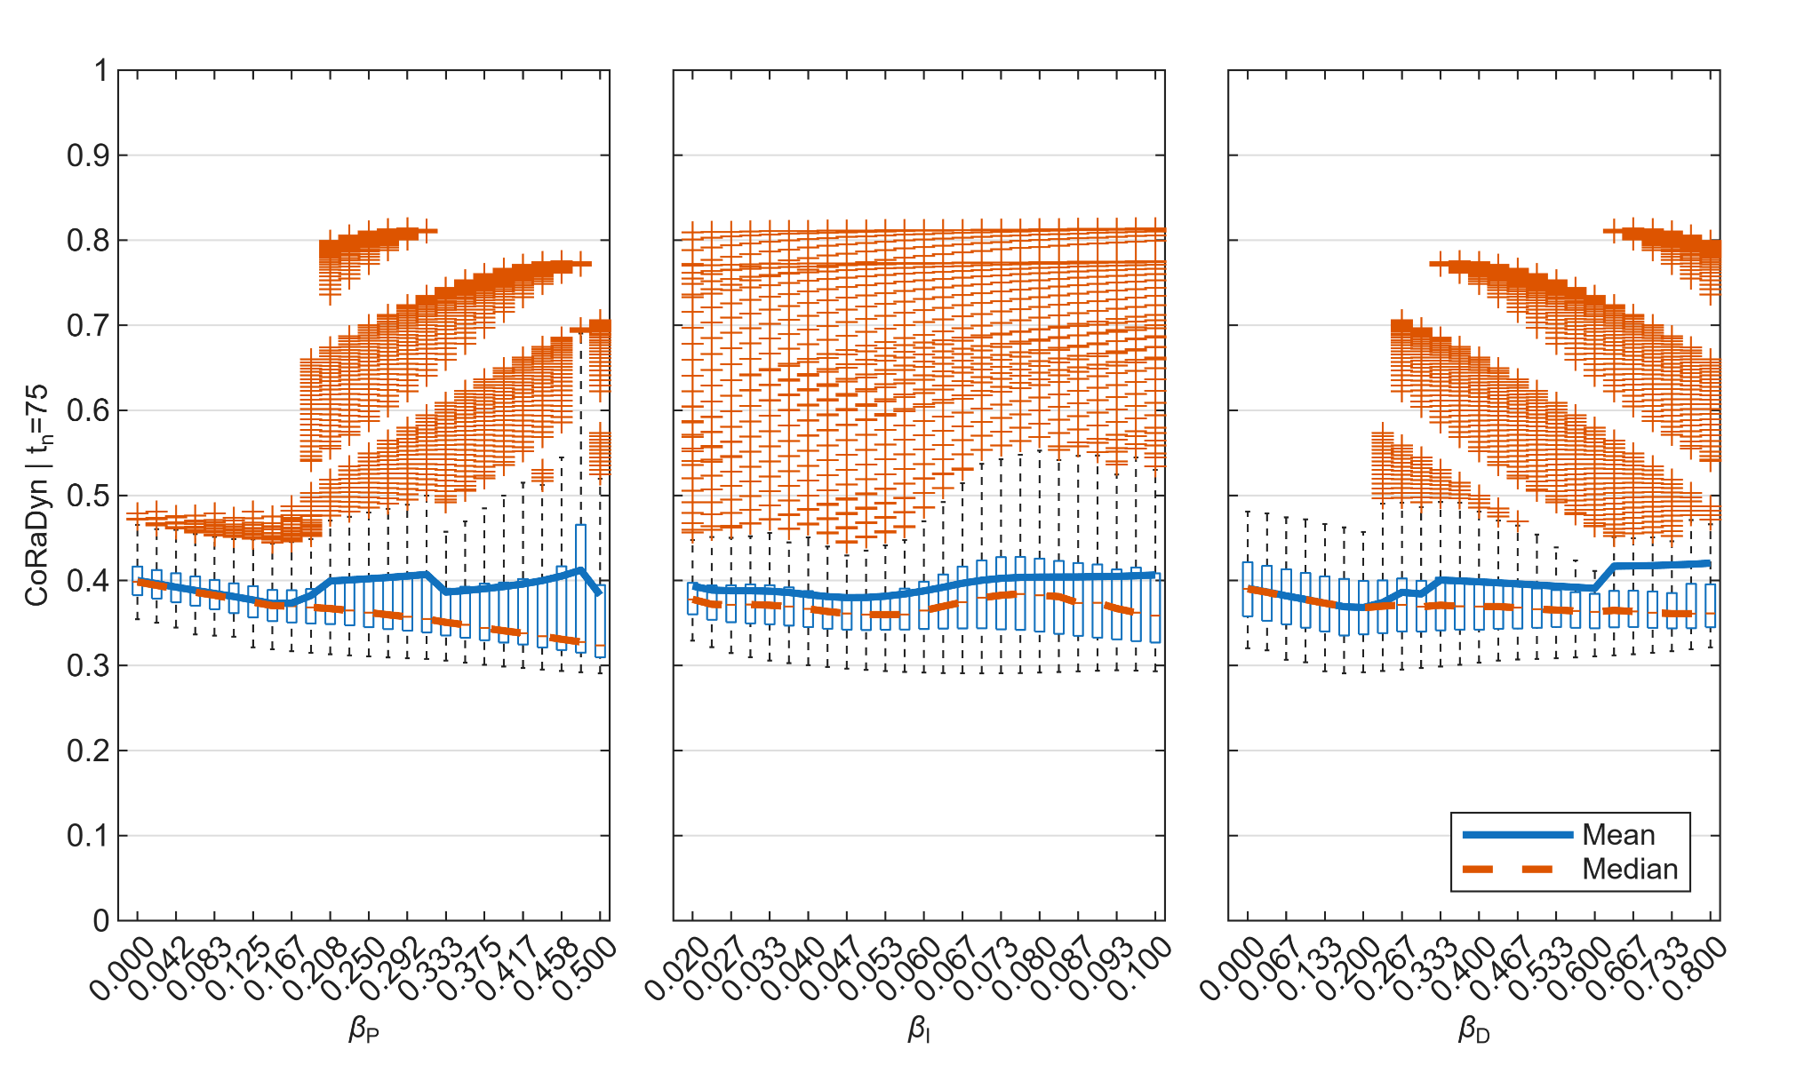
Distribution of CoRaDyn values across PID controller weights at min. Boxplots of CoRaDyn for fixed values of the proportional (; left), integral (; center), and derivative (; right) control weights. For each control weight value, the distribution is computed over all combinations of the remaining two controller weights. Blue lines denote the mean and red lines the median. See Supplementary Information for equations and Table 3 for parameter values.
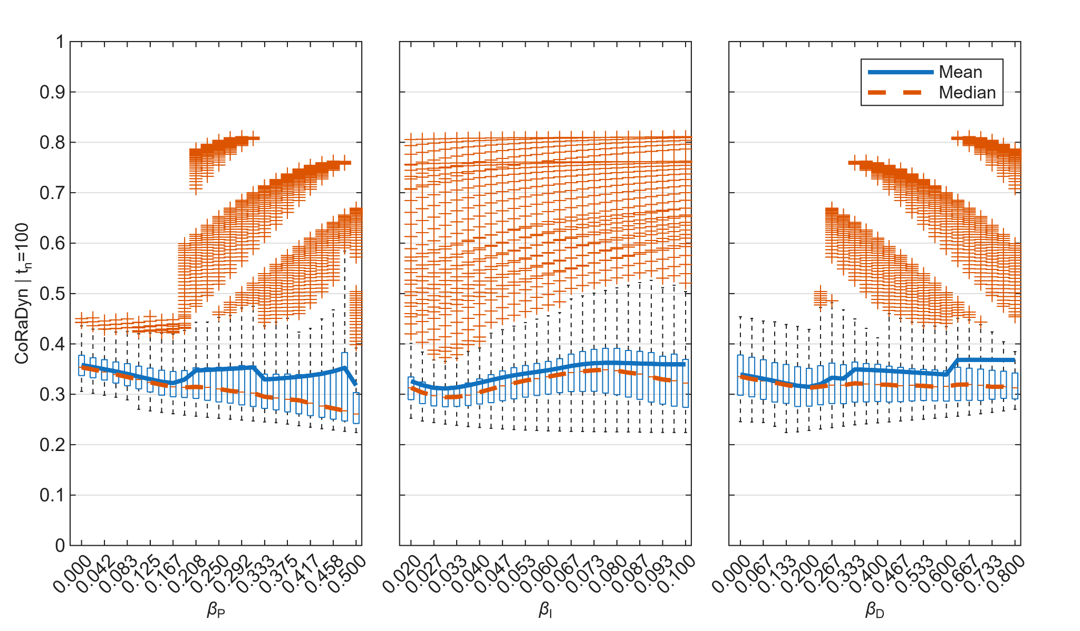
Distribution of CoRaDyn values across PID controller weights at min. Boxplots of CoRaDyn for fixed values of the proportional (; left), integral (; center), and derivative (; right) control weights. For each control weight value, the distribution is computed over all combinations of the remaining two controller weights. Blue lines denote the mean and red lines the median. See Supplementary Information for equations and Table 3 for parameter values.
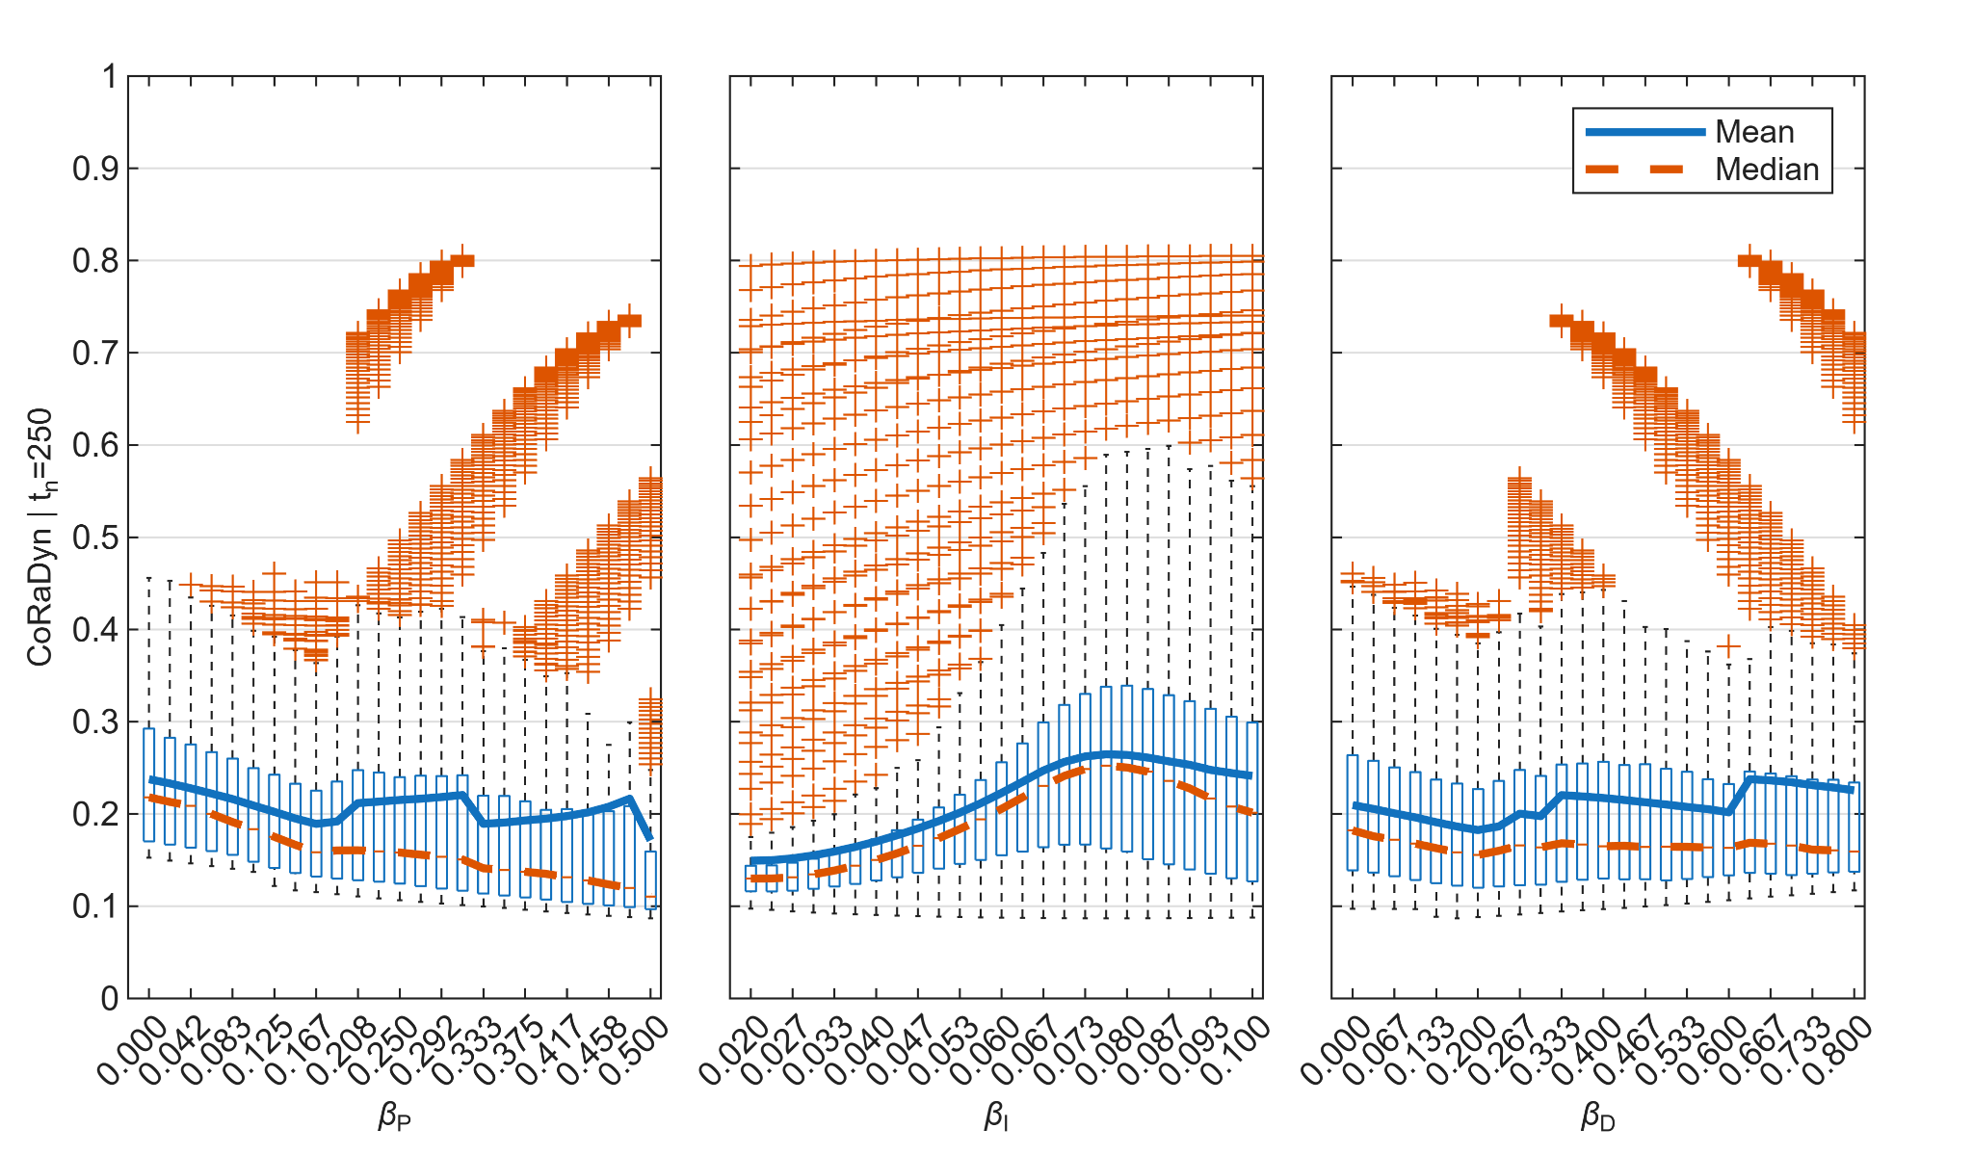
Distribution of CoRaDyn values across PID controller weights at min. Boxplots of CoRaDyn for fixed values of the proportional (; left), integral (; center), and derivative (; right) control weights. For each control weight value, the distribution is computed over all combinations of the remaining two controller weights. Blue lines denote the mean and red lines the median. See Supplementary Information for equations and Table 3 for parameter values.
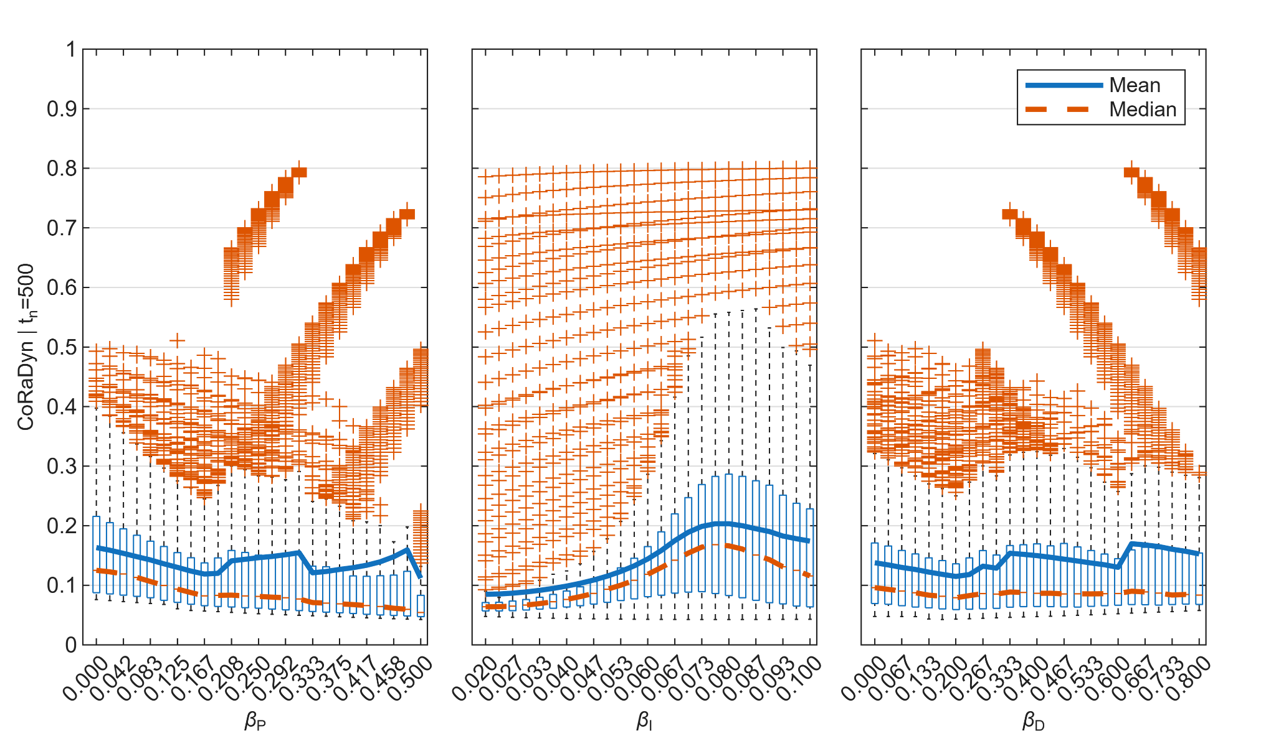
Distribution of CoRaDyn values across PID controller weights at min. Boxplots of CoRaDyn for fixed values of the proportional (; left), integral (; center), and derivative (; right) control weights. For each control weight value, the distribution is computed over all combinations of the remaining two controller weights. Blue lines denote the mean and red lines the median. See Supplementary Information for equations and Table 3 for parameter values.
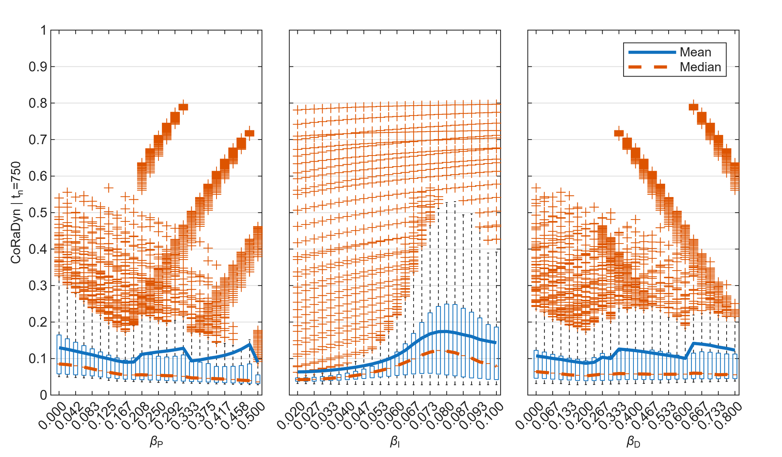
Distribution of CoRaDyn values across PID controller weights at min. Boxplots of CoRaDyn for fixed values of the proportional (; left), integral (; center), and derivative (; right) control weights. For each control weight value, the distribution is computed over all combinations of the remaining two controller weights. Blue lines denote the mean and red lines the median. See Supplementary Information for equations and Table 3 for parameter values.
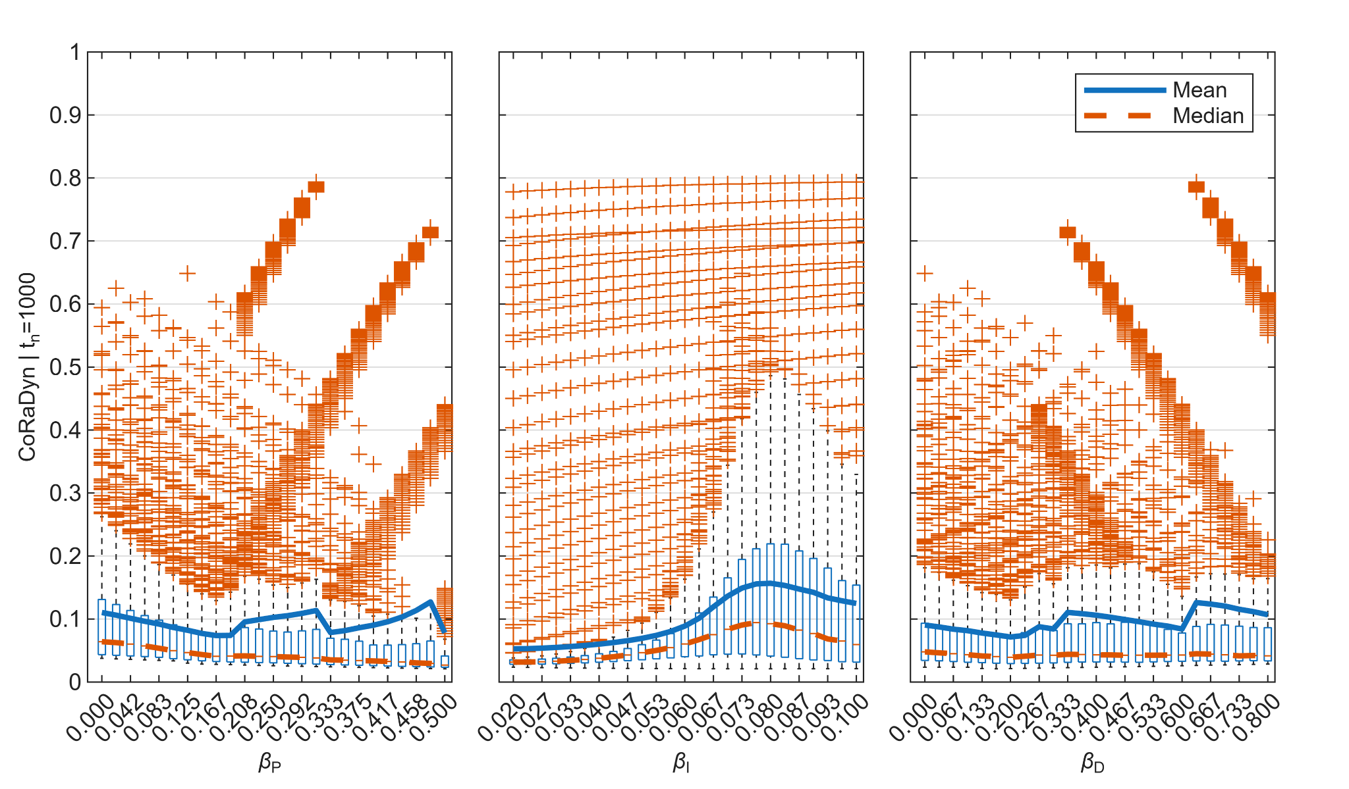
Distribution of CoRaDyn values across PID controller weights at min. Boxplots of CoRaDyn for fixed values of the proportional (; left), integral (; center), and derivative (; right) control weights. For each control weight value, the distribution is computed over all combinations of the remaining two controller weights. Blue lines denote the mean and red lines the median. See Supplementary Information for equations and Table 3 for parameter values.
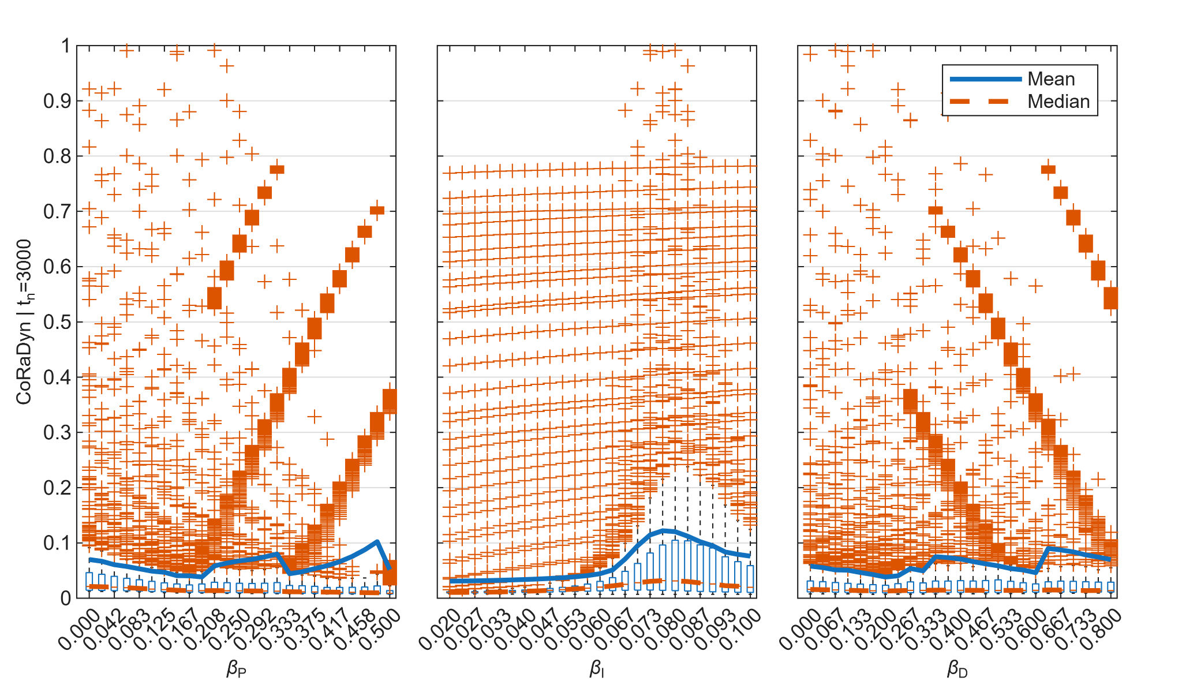
Distribution of CoRaDyn values across PID controller weights at min. Boxplots of CoRaDyn for fixed values of the proportional (; left), integral (; center), and derivative (; right) control weights. For each control weight value, the distribution is computed over all combinations of the remaining two controller weights. Blue lines denote the mean and red lines the median. See Supplementary Information for equations and Table 3 for parameter values.
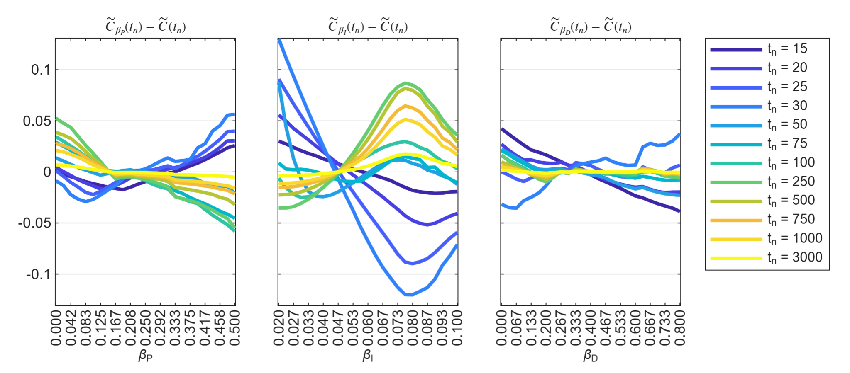
Deviations from the global median CoRaDyn across evaluation times. Differences between the median CoRaDyn associated with each controller weight and the corresponding global median, (left), (center), and (right), shown as functions of the corresponding controller weight. Within each panel, colored curves represent different evaluation times (; see legend). This representation facilitates comparison of how the influence of each controller weight evolves throughout the adaptive response. See Supplementary Information for equations and Table 3 for parameter values.
Capabilities of different frameworks for evaluating biological feedback control.
Comparison of adaptation time, CoRa, and CoRaDyn with respect to the types of feedback behavior they can evaluate and the questions they address.
Capability | Adaptation Time | CoRa | CoRaDyn
Quantifies steady-state adaptation | –
Quantifies transient feedback performance | Limited | –
Defined for sustained post-perturbation oscillations | – | –
Distinguishes controllers with identical steady-state adaptation | – | –
Allows evaluation at arbitrary temporal scales | – | –
Isolates the contribution of individual feedback loops through controlled comparison | – | Proposed
Requires a stable pre-perturbation steady state
As proposed in Chevalier et al. (2019).
As proposed in Gómez-Schiavon & El-Samad (2022).
CoRaDyn converges to CoRa in the long-time limit for systems that reach a stable post-perturbation steady state.
The use of locally analogous systems to isolate individual feedback loops was discussed in the original CoRa formulation, but was not explicitly demonstrated.
Used parameter values in main figures.
Figure | CoRaDyn parameters | Model parameters
Fig. 2A | Model: Eqs. [SEq:dZ1] - [SEq:dXC]  Controlled variable, :  Perturbed parameter, :  Perturbed size, : | , , , , , , , , , , , , , , , ,
Fig. 2B | Model: Eqs. [SEq:dZ1] - [SEq:dXC]  Controlled variable, :  Perturbed parameter, :  Perturbed size, :  Characterization parameter, : | , , , , , , , , , , , , , , , ,
Fig. 2C | Model: Eqs. [SEq:dZ1] - [SEq:dXC]  Controlled variable, :  Perturbed parameter, :  Perturbed size, :  Characterization parameter, :  Evaluation time, : | , , , , , , , , , , , , , , , ,
Fig. 3B-F | Model: Eqs. [SEq:dZ1] - [SEq:dXC]  Controlled variable, :  Perturbed parameter, :  Perturbed size, : | , , , , , , , , , , , , , , , ,
Fig. 4A-C | Model: Eqs. [SEq:dZ1] - [SEq:dXC]  Controlled variable, :  Perturbed parameter, :  Perturbed size, :  Evaluation time, : | , , , , , , , , , , , , , , , ,
Fig. 5A-D | Model: Eqs. [SEq:dZ1] - [SEq:dXC]  Controlled variable, :  Perturbed parameter, :  Perturbed size, : | , , , , , , , , , , , , , , , ,

Used parameter values in supplementary figures.
Figure | CoRaDyn parameters | Model parameters
Fig. 6 | Model: Eqs. [SEq:dZ1] - [SEq:dXC]  Controlled variable, :  Perturbed parameter, :  Perturbed size, : | , , , , , , , , , , , , , , , ,
Fig. 7 | Model: Eqs. [SEq:dZ1] - [SEq:dXC]  Controlled variable, :  Perturbed parameter, :  Perturbed size, :  Evaluation time, : | , , , , , , , , , , , , , , , ,
Fig. 8 - 20 | Model: Eqs. [SEq:dZ1] - [SEq:dXC]  Controlled variable, :  Perturbed parameter, :  Perturbed size, :  Evaluation time, : | , , , , , , , , , , , , , , , ,

S1 CoRaDyn approach
CoRaDyn builds on CoRa (Control Ratio), a method that quantifies how much feedback control contributes to a system’s ability to reject step perturbations (Gómez-Schiavon & El-Samad, 2022). Whereas CoRa evaluates feedback performance exclusively at steady state, CoRaDyn extends the framework to quantify feedback performance throughout the transient response, before steady state is reached. This provides complementary information by capturing dynamic features such as the magnitude of the initial deviation and the time required for the system to relax toward steady state.
To perform the analysis, both CoRa and CoRaDyn rely on a mathematically controlled comparison between two systems. One is the feedback system, which implements feedback control. The other is a locally analogous system, identical in structure and parameter values except for the removal of a single interaction that breaks the feedback loop under evaluation. This interaction is replaced with a constant input calibrated to reproduce the effect of the feedback at the steady state of the feedback system for the parameter set .
The locally analogous system is constructed to ensure internal equivalence, such that all variables, biochemical reactions, parameter values, and interactions remain identical to those of the feedback system, except for the single interaction removed to disrupt the feedback mechanism under evaluation. It also ensures external equivalence, allowing both systems to converge to the same steady state. Consequently, any differences in the dynamics of the two systems following a small perturbation 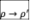, where , can be attributed exclusively to the functional contribution of the feedback mechanism.
To quantify these differences, CoRa compares the output of the feedback and locally analogous systems at a specified evaluation time, typically after both systems have reached steady state following a perturbation to . Let denote the steady-state value of the feedback system, and that of the locally analogous system for a given parameter set . By construction, these values are identical, i.e., 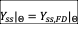. Following a perturbation , the corresponding steady-state outputs become 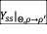 and 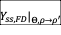, respectively. CoRa is then defined as:
$$\begin{eqnarray} {\rm CoRa}_{\theta\in\Theta}(\rho) &=& \frac{\Delta \rm{log}(Y_{ss})|_{\Theta,\rho \rightarrow \rho^{\prime}}}{\Delta \rm{log}(Y_{ss,FD})|_{\Theta,\rho \rightarrow \rho^{\prime}}} \label{SEq:DY} \\ &=& \frac{{\rm log}(Y_{ss}|_{\Theta,\rho \rightarrow \rho^{\prime}}) - {\rm log}(Y_{ss}|_{\Theta})}{{\rm log}(Y_{ss,FD}|_{\Theta,\rho \rightarrow \rho^{\prime}}) - {\rm log}(Y_{ss,FD}|_{\Theta})} \nonumber \\ &=& \frac{{\rm log}\Big(\frac{Y_{ss}|_{\Theta,\rho \rightarrow \rho^{\prime}}}{Y_{ss}|_{\Theta}}\Big)}{{\rm log}\Big(\frac{Y_{ss,FD}|_{\Theta,\rho \rightarrow \rho^{\prime}}}{Y_{ss,FD}|_{\Theta}}\Big)} \nonumber \end{eqnarray}$$
CoRaDyn, in contrast, quantifies the behavioral disparity between the feedback and locally analogous systems by integrating the deviation in the system output relative to its pre-perturbation state over time. Specifically, it evaluates this quantity from the time the perturbation is applied () to a chosen evaluation time (), and compares the resulting cumulative deviation with that of the locally analogous system. To ensure a fair comparison, both integrals are normalized by the duration of the evaluation window (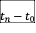), although this normalization cancels in the final ratio. CoRaDyn is therefore defined as:
$$\begin{eqnarray} {\rm CoRaDyn}_{\Theta}(Y,\rho,t_n) &=& \frac{{\int_{t_0}^{t_n} \left| \Delta \log Y(t) \right| dt}}{{\int_{t_0}^{t_n} \left| \Delta \log Y_{FD}(t) \right| dt}} \label{SEq:IntY} \\ &=& \frac{{\int_{t_0}^{t_n} \left| {\rm log}(Y|_{\Theta,\rho \rightarrow \rho^{\prime}}) - {\rm log}(Y|_{\Theta}) \right| dt}}{{\int_{t_0}^{t_n} \left| {\rm log}(Y_{FD}|_{\Theta,\rho \rightarrow \rho^{\prime}}) - {\rm log}(Y_{FD}|_{\Theta}) \right| dt}} \nonumber \\ &=& \frac{{\int_{t_0}^{t_n} \left| {\rm log}\Big(\frac{Y|_{\Theta,\rho \rightarrow \rho^{\prime}}}{Y|_{\Theta}}\Big) \right| dt}}{{\int_{t_0}^{t_n} \left| {\rm log}\Big(\frac{Y_{FD}|_{\Theta,\rho \rightarrow \rho^{\prime}}}{Y_{FD}|_{\Theta}}\Big) \right| dt}} \nonumber \end{eqnarray}$$
Here, and denote the output trajectories of the feedback and locally analogous systems, respectively, prior to the perturbation. Likewise, 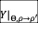 and 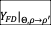 denote the corresponding trajectories following the perturbation , where .
Like CoRa, CoRaDyn yields a real number between 0 and 1. ${\rm CoRaDyn}_{\Theta}(Y,\rho,t_n)$ approaches 0 when the feedback effectively attenuates the impact of the perturbation over the evaluation window, relative to the locally analogous system. This occurs when 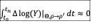, causing the ratio to become small. However, because CoRaDyn accumulates deviations throughout the evaluation window, transient dynamics occurring before the system reaches steady state contribute to the metric, even when perfect adaptation is ultimately achieved (i.e., 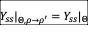). Consequently, systems exhibiting perfect adaptation generally yield positive CoRaDyn values over finite evaluation windows.
As ${\rm CoRaDyn}_{\Theta}(Y,\rho,t_n)$ increases, it reflects a diminished contribution of feedback to perturbation rejection over the evaluation window. Nonetheless, as long as its value remains strictly between 0 and 1, feedback still reduces the effect of the perturbation relative to the locally analogous system, as reflected by the inequality
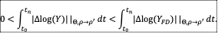
When ${\rm CoRaDyn}_{\Theta}(Y,\rho,t_n) = 1$, feedback has no effect on the system’s response over the evaluation window, making the output trajectory indistinguishable from that of the feedback-disrupted system:
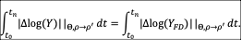
A defining feature of CoRaDyn is its dependence on , which determines the duration of the evaluation window and thereby influences the resulting value. When the system reaches a steady state after the perturbation , increasing progressively reduces the relative contribution of transient dynamics. Consequently, the steady-state behavior dominates, and CoRaDyn converges to the corresponding CoRa value for the same parameter set . Conversely, as approaches , CoRaDyn approaches 1 because the outputs of the feedback and feedback-disrupted systems are initially nearly identical by construction. Only after sufficient time has elapsed (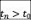) does the corrective action of the feedback produce measurable differences between the trajectories of the two systems.
The choice of the evaluation time is inherently context dependent and should be guided by the temporal characteristics of the biological system or mathematical model under study. For example, may correspond to the time required for the system to reach a stable steady state or to settle into a limit cycle following a perturbation. Alternatively, it may be informed by empirical observations of the timescale over which a biological system typically mounts an effective corrective response. More generally, should be chosen to reflect the timescales of the processes being evaluated. For instance, if the relevant dynamics occur over seconds, as in fast molecular interactions, selecting on the order of seconds rather than minutes or hours ensures that the resulting CoRaDyn values capture the biologically relevant behavior.
In addition to the evaluation time, the perturbation magnitude is another important consideration when computing CoRaDyn. Whereas CoRa is approximately independent of perturbation size, provided the perturbation remains sufficiently small, CoRaDyn can be sensitive to it. This is because CoRaDyn captures features of the system’s full dynamical response, including response amplitude, adaptation time, and transient excursions, all of which may vary with perturbation magnitude. For example, in systems exhibiting damped oscillations, larger perturbations can prolong transients or amplify the output response, thereby altering the CoRaDyn value (Fig. 6). Furthermore, this sensitivity depends not only on the system’s dynamical regime but also on the evaluation time . Shorter evaluation windows place greater emphasis on early-time dynamics, which are generally more sensitive to perturbation magnitude. In addition, sufficiently large perturbations may drive the system outside the regime in which the feedback and feedback-disrupted systems remain locally analogous, introducing differences that are no longer attributable solely to the presence or absence of feedback. Therefore, small perturbations are generally preferred to preserve local analogy and ensure a meaningful comparison. Nevertheless, the appropriate perturbation magnitude should ultimately be determined on a case-by-case basis by assessing its influence on both the system dynamics and the resulting CoRaDyn value.
Finally, interpreting CoRaDyn values requires careful consideration. Lower values do not necessarily indicate better system performance, since different dynamic responses may be advantageous depending on the physiological context and functional objectives of the system. For example, when the goal is to maintain an output close to its pre-perturbation level throughout the evaluation window, lower CoRaDyn values are generally desirable. In contrast, systems that rely on transient responses, such as pulsatile signaling or delayed adaptation, may naturally exhibit higher CoRaDyn values while still achieving their intended function. The key question is whether feedback improves system behavior relative to its feedback-disrupted counterpart with respect to the biological function under consideration. Values approaching one indicate that feedback contributes little to the system’s response, as the feedback and feedback-disrupted systems behave similarly over the evaluation window. Beyond this, no universal threshold exists; the interpretation of CoRaDyn values ultimately depends on the physiological constraints and functional objectives of the system.

S2 Biomolecular PID controller as a case study

0.0.0.13 Adaptation of the PID system proposed by Chevalier et al. (2019).
The model proposed by Chevalier et al. (2019) extends the antithetic integral feedback motif introduced by Briat et al. (2016) to implement modular proportional, integral, and derivative (PID) control.
The core network comprises four molecular species connected through three regulatory interactions. At its center is the antithetic motif, formed by the controller species and , which undergo a mutual annihilation reaction. This interaction sequesters both controller species through stoichiometric binding, thereby implementing the integral feedback mechanism. In this architecture, activates the production of , which in turn drives the production of the system output, . The output subsequently induces the production of , thereby closing the feedback loop. As a result, the feedback maintains at its target level despite persistent disturbances.
The dynamics of this PID feedback system are described by the following set of differential equations:
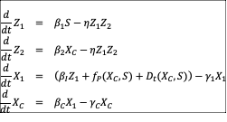
Here, represents the input signal; introduces integral control through the antithetic feedback motif; 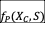 represents proportional control (Eq. [SEq:fP]); and 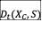 represents derivative control (Eqs. [SEq:dA]–[SEq:Dt]). Together, these terms integrate integral, proportional, and derivative feedback into a unified PID control architecture that combines robust perfect adaptation with tunable transient dynamics.
Proportional control is implemented through an inhibitory function that modulates the production of in response to deviations in . Specifically, this term is defined as:
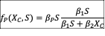
This formulation enables the strength of production to vary proportionally with the difference between the desired and actual output levels, thereby contributing to proportional feedback control.
The derivative control component is implemented through a two-node dynamical module that approximates the time derivative of . This module consists of two additional species, and , whose dynamics are described by the following equations:
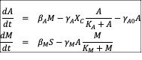
The derivative term is then defined as
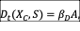
where provides a dynamical approximation of the temporal changes in , enabling the system to adjust its response based on derivative feedback.

0.0.0.14 Locally analogous feedback-disrupted systems for the PID system.
To evaluate how PID control contributes to the system’s transient dynamics and disturbance rejection capacity using CoRaDyn, we construct the corresponding locally analogous feedback-disrupted systems. Because the PID controller comprises three distinct feedback components—integral, proportional, and derivative control—we construct component-specific feedback-disrupted systems in which only the interaction associated with the feedback mechanism under evaluation is disrupted. In addition, we construct a fully feedback-disrupted system in which all three feedback loops are simultaneously disrupted, providing a reference for evaluating the overall contribution of PID control.
To disrupt the contribution of all three feedback components, we remove the interaction between and that closes the antithetic integral feedback loop. The fully feedback-disrupted system is obtained by replacing Eq. [SEq:dZ2] with:
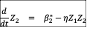
where 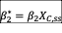 is calibrated to preserve the pre-perturbation steady state.
To disrupt individual feedback components, we instead modify Eq. [SEq:dX1]. When proportional feedback is disrupted, the dynamic proportional term is replaced by its steady-state equivalent:
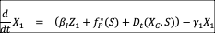
where
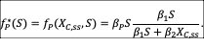
Similarly, when derivative feedback is disrupted, the dynamic derivative term is replaced by its steady-state equivalent:
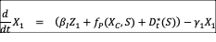
where
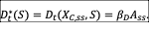
Finally, to disrupt both proportional and derivative feedback, both dynamic terms are replaced by their steady-state equivalents:
